Family Justice Services
in New Zealand
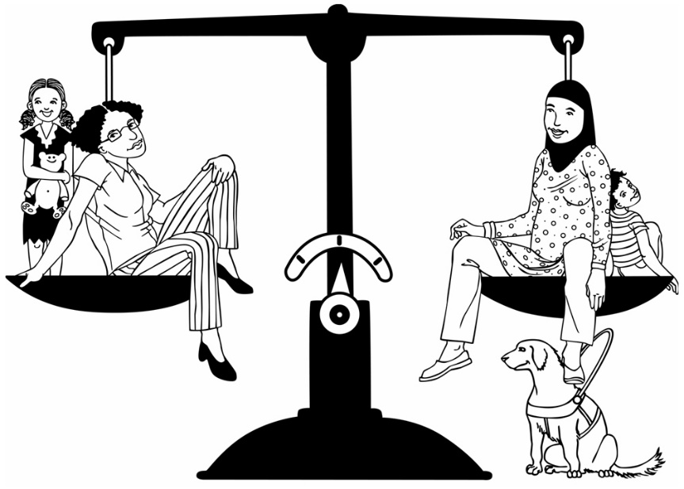

What needs to change?

Before you get started
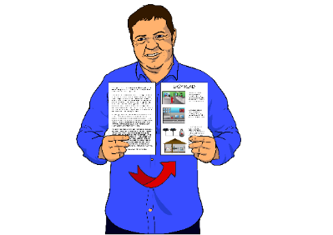
This document is in Easy Read but it is long.

Here are some things you can do to make it easier to read:
- read a few pages at a time

- go to What is in this book on page 2 to find the parts you want to read.
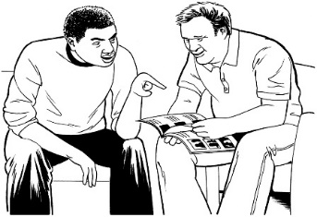
- have someone assist you to understand it.

What is in this book?

Page

What is this document about? 6

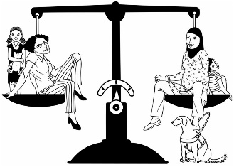
What are family justice
services? 7

Who are the people who made
this report? 9

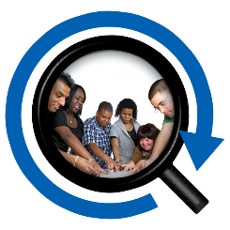
How did we make our
report? 10

Our full report 11

Page
The words we use for people
who look after children 13

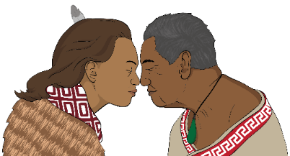
Our main idea – Te Korowai
Ture ā-Whānau 14

How we organised our report 16
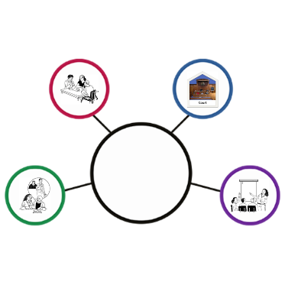

Things that affect all family
justice services 18
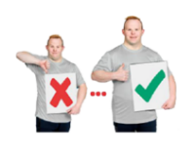

What needs to happen for all
family justice services? 20

Page
Making the Family Court
work better 24

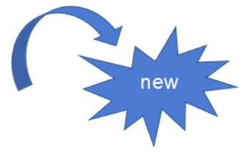
What changed for the
Family Court? 25

What needs to happen with
the Family Court? 28
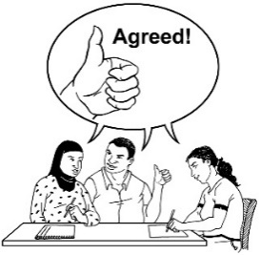

Supporting families to agree 32

What changed for services that
support families? 34

Page
What needs to happen for
services that support families? 37

Looking to the future 40

What needs to happen in
the future? 42

Last thoughts 44

What is this document about?
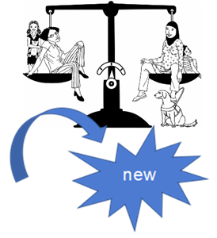
In 2014 there were big changes to family justice services in New Zealand.

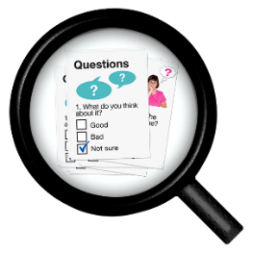
In 2018 the Minister of Justice asked us to see if these changes are working in a good way.
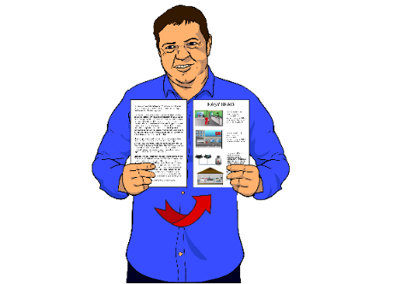
This document has information about our report for the Minister of Justice.

What are family justice services?

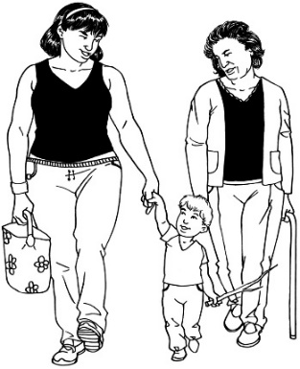
Family justice services help parents and whānau work out the best way to care for their children.

Sometimes when parents separate they will use family justice services.
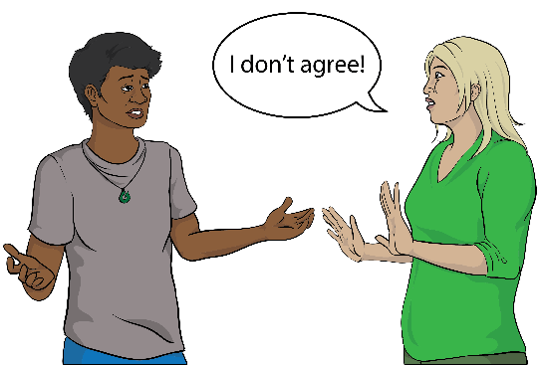
To separate is the same as:
- breaking up

- not living together any more

- not being married any more.

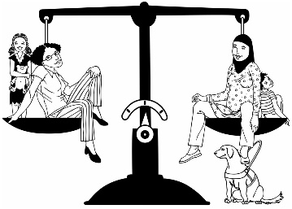
Family justice services are things like:
- Family Dispute Resolution
- the Parenting Through Separation course

- the Family Court.
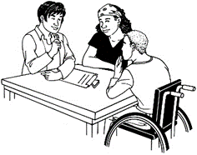
There is more information about:
- Family Dispute Resolution on page 35.
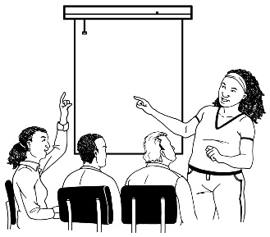
- the Parenting Through Separation course on page 36.

Who are the people

who made this report?

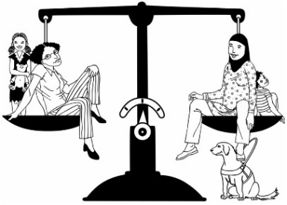
We are a group of 3 people who know about:
- family justice services

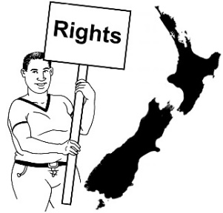
- human rights.

Our names are:
- Rosslyn Noonan

- Chris Dellabarca

- La-Verne King.

How did we make our report?

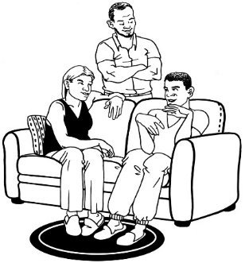
In September and November 2018 we asked what family justice services are like for:
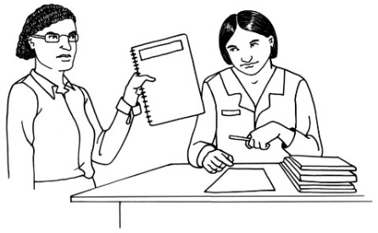
- parents and whānau who use the services

- people who work for family justice services.
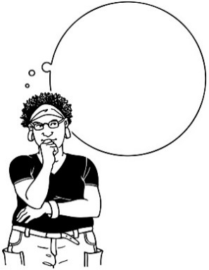
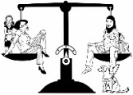
In February and March 2019 we asked people to look at our ideas for making family justice services better.

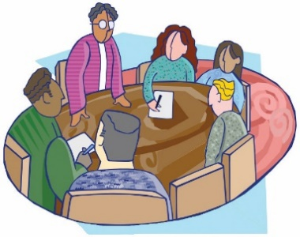
We also:
- talked to other people who know a lot about family justice services

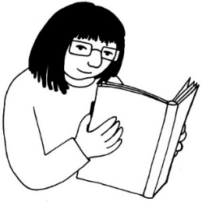
- looked at information that other people had collected about family justice services.

Our full report
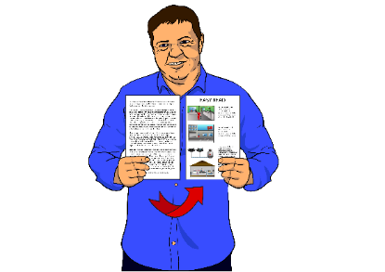
This book has information about our report.

This book has some information about:
- the changes that happened in 2014
- how family justice services are working
- what needs to change so that family justice services work better.

If you want to see our full report you can go to this website:

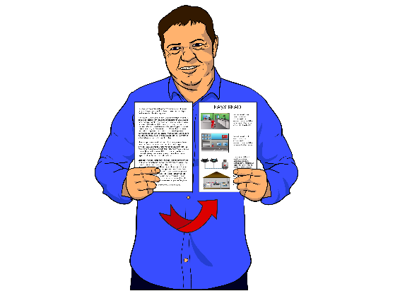
https://www.justice.govt.nz/assets/Documents/Publications/family-justice-reforms-final-report-independent-panel.pdf

The report is not in Easy Read.
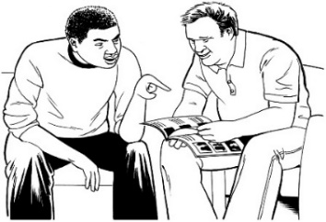
You may need to ask someone to assist you to read it.

The words we use for people who

look after children
In our report we used the words parents and whānau to talk about all the people who look after children.

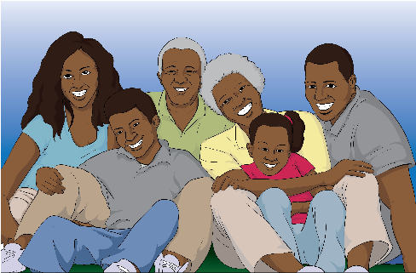
Whānau means wider family.

Whānau is more than just parents and children.
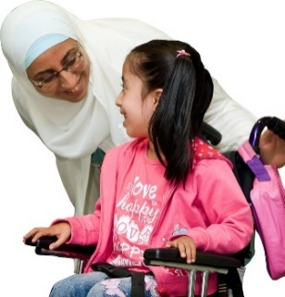
People who look after children might have other words for themselves too like:
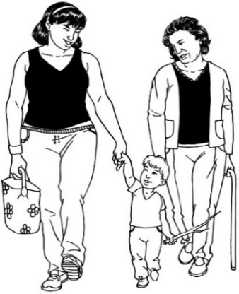
- caregivers
- guardians
- grandparents
- family
- friends.

Our main idea

Te Korowai Ture ā-Whānau
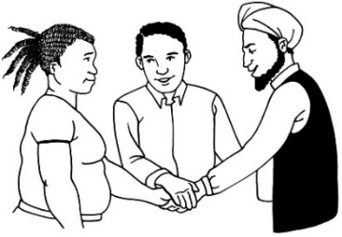
We think that family justice services should join together and be called Te Korowai Ture ā-Whānau
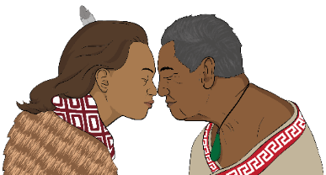
A korowai is a cloak.

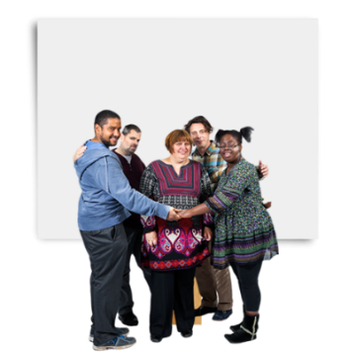
We want family justice services to be like a korowai for parents and whānau so that when they use family justice services they are:
- safe

- supported to find their own strength

- treated with respect.

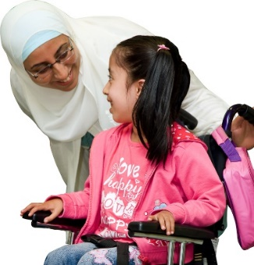
Te Korowai Ture ā-Whānau would put children and whānau at the centre of family justice services.
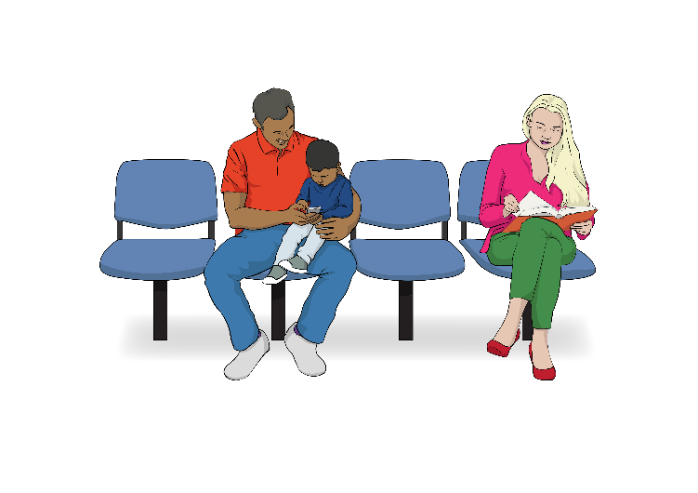
Parents and whānau would have choices so they can use the service they need:
- at the right time

- in a way that works for them.
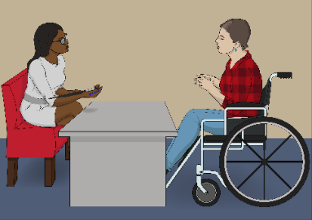
Te Korowai Ture ā-Whānau would:
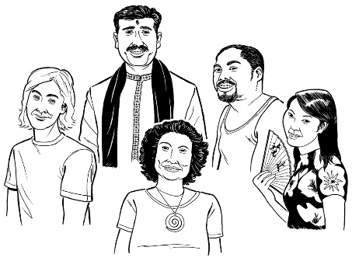
- work with the different needs of different people

- work for people from different cultures.

How we organised our report
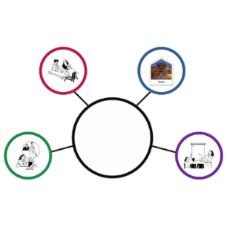
We have made our report in 4 parts:

- Things that affect all family justice services.
- Making the Family Court work better.
- Encouraging parents and whānau to agree.
- Looking to the future.

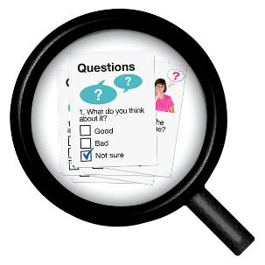
In every part of the report we talk about:
- what we learned

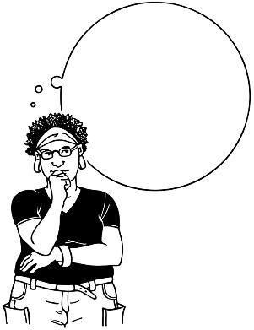
- what we think needs to happen to make family justice services better.

In this Easy Read document there is also extra information to explain some of the 2014 changes.

Things that affect all

family justice services

The things that make it hard for people to use family justice services are often the same things that are hard in other parts of their life.
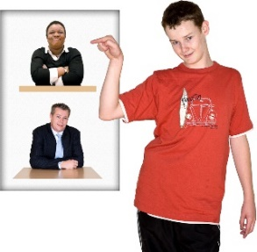
Here are some examples:
- Often children do not get a say in decisions that affect them.
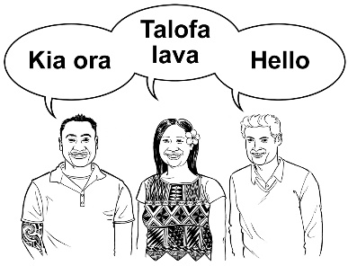
- The services only work for 1 culture.

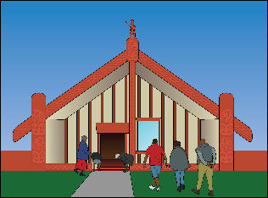
- Māori ways of doing things are not seen as important.

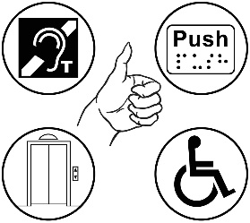
- The services are not set up to meet the needs of disabled people.
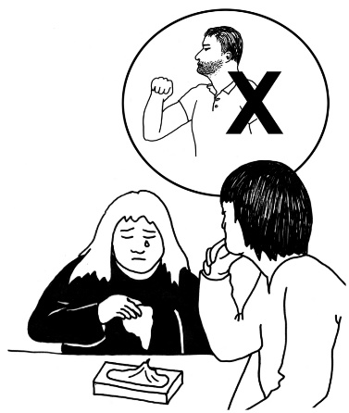
Sometimes services are not sure what is the best way to keep children safe from family violence.

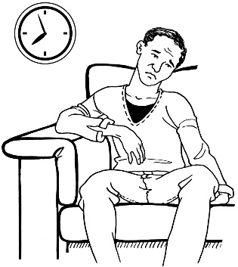
Family violence is when someone is hurt by another person in their family.

Often services work too slowly.

This causes problems.
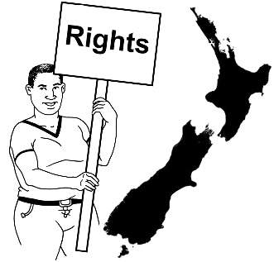
Family justice services have not been set up to look after human rights.

What needs to happen for all family justice services?
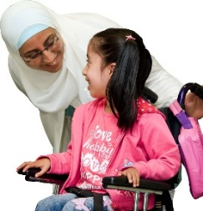
We need to work out the best ways to make sure children are listened to.

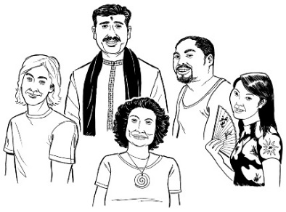
There needs to be a plan for how family justice services can meet the needs of people from all different cultures.
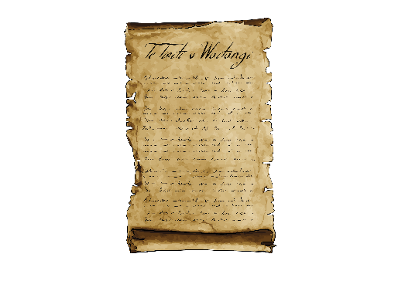
Family justice services need to change so that they stick to what was agreed in the Treaty of Waitangi.

The Treaty of Waitangi is an agreement between Māori people and the government.

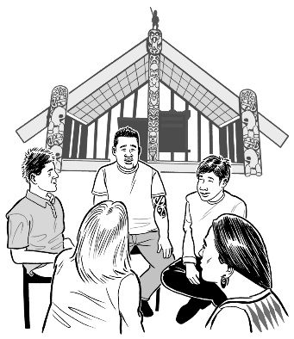
Here are some things that would help family justice services stick to what was agreed in the Treaty of Waitangi:
- teaching people who work in the services to understand Māori ways of doing things
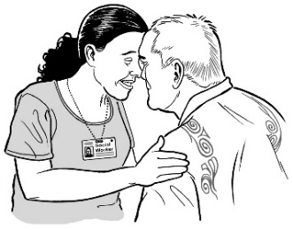
- supporting family justice services that already work in a Māori way

- more Māori judges
- using cultural reports more often.

In the Family Court the judge:
- listens to everyone

- decides what should happen.
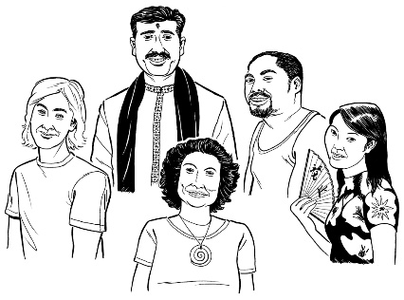
A judge can ask for a cultural report to help them understand a child’s culture.
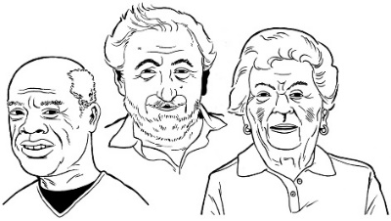
We need to find ways to include grandparents and other people from the family / whānau.
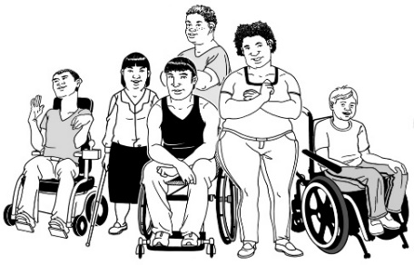
People working in family justice services need to learn more about disability issues.
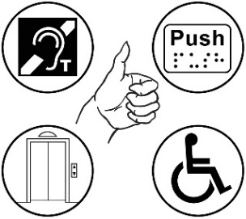
We should ask people what support they need when they first ask the Family Court for help.
We need to make sure disabled people can get information in a way that is good for them.
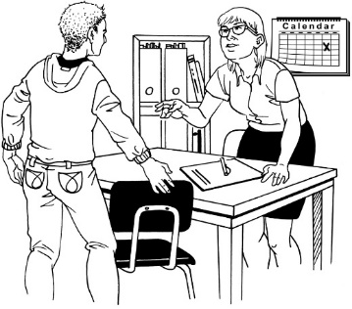
Disabled children should get a lawyer who knows how to work well with them.

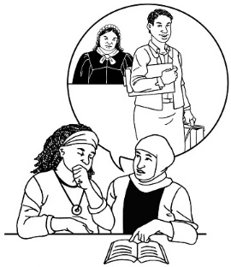
A lawyer is a person who:
- knows about the law

- can speak for you in court
- can help you with important paperwork.

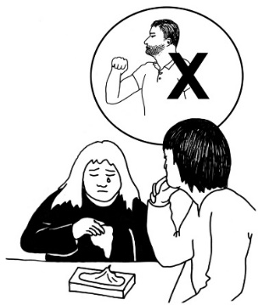
Everyone who works in family justice services needs to learn more about family violence.
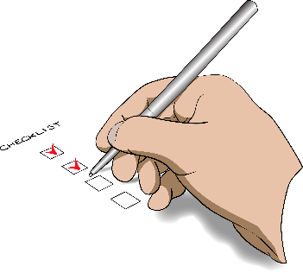
There should be a list of things for the judge to check when they are deciding if a child is safe.
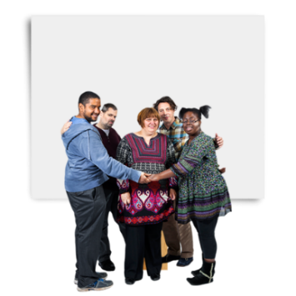
If someone has been hurt by a person in their family we need to make sure they will be safe in court.

Making the Family Court work better
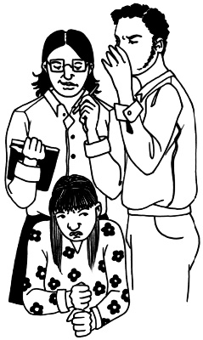
Some of the people we spoke to felt they were treated very badly by the Family Court.

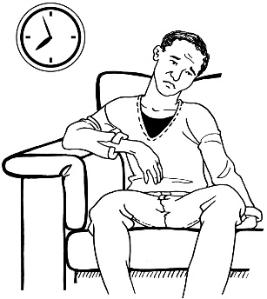
Often the Family Court works much too slowly.

This makes people trust the court less.
It can also make arguments between family members worse.
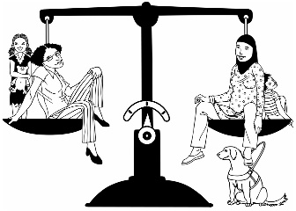
The changes that happened in 2014 were meant to help with this.
But some of the changes seem to have made things worse.

What changed for the Family Court?

There are more without notice applications
When people want the Family Court to make a decision about who will look after a child they make an application.
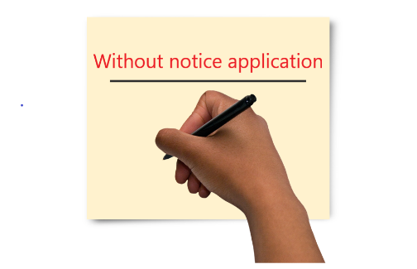
If a decision needs to be made quickly they should make a without notice application.
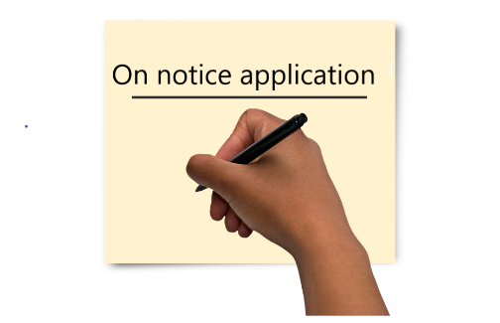
If a decision does not need to be made quickly they should make an on notice application.
Since 2014 there have been a lot more without notice applications.

Getting help from a lawyer

Since 2014 it has been harder to get help from a lawyer to deal with the Family Court.
If people make a without notice application they can get more help from a lawyer.

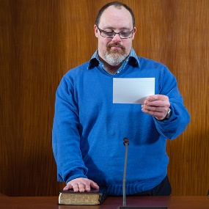
When they cannot get a lawyer people have to speak for themselves in court.
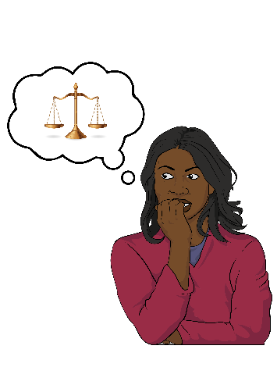
This can be really hard for people who have never spoken in court before.

It also slows down the Family Court.

Other changes
Since 2014 people who go to Family Court have had to pay for some of the costs of the court case.

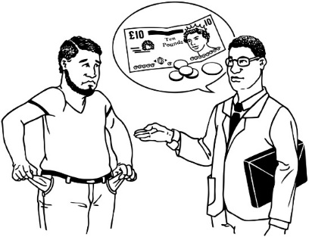
Sometimes a person may not be asked to pay because:
- they do not have much money

- it would make it hard for their family.

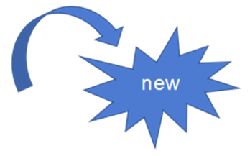
There have been changes to the way that the court works out how safe children are.

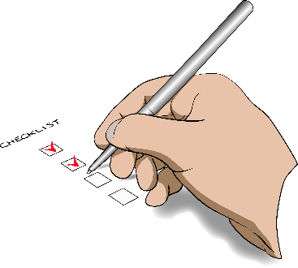
There have also been changes to the job of the lawyer who speaks for children in court cases.

What needs to happen with the

Family Court?
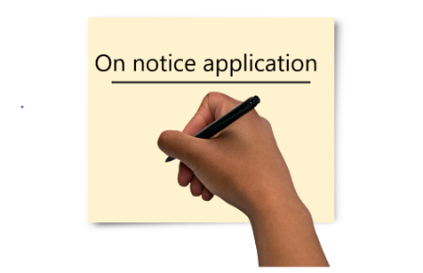
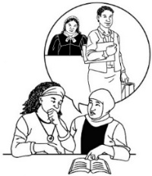
Parents and whānau who make an on notice application should be able to get more help from a lawyer.

When people make a without notice application we should ask them why it needs to be without notice.

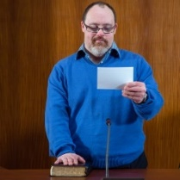
There should be better information to help people who speak for themselves in court.

Judges need to do less work organising things so they can have more time to listen to cases.
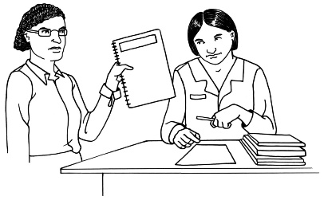
Some of their work could be done by a Senior Family Court Registrar.
We need more judges.

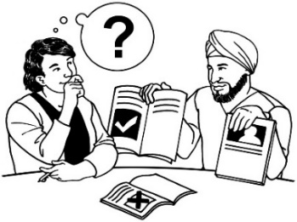
There should be Family Justice Coordinators who:
- give information to parents and whānau
- encourage parents and whānau to use the services that will help them.

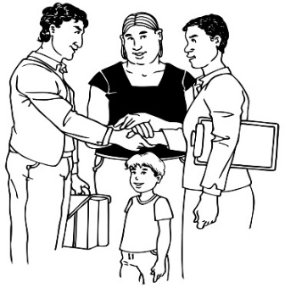
There needs to be changes to:
- how the lawyers that speak for children are chosen

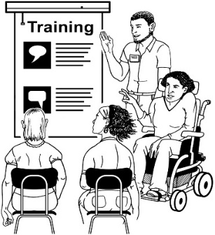
- how the lawyers that speak for children are trained to do their job.

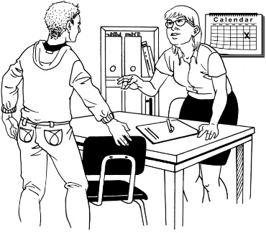
These lawyers who speak for children need to explain to children what is happening.

Māori children should get a Māori lawyer to represent them.

Complex cases should be looked after by:
- judges who know the case well
and
- the Senior Family Court Registrar.
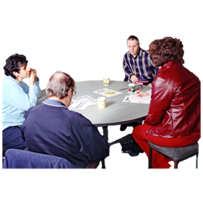
A complex case has many things about it that make it hard to work out how to make things better.
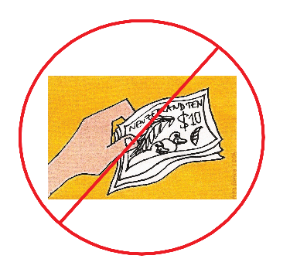

People should not have to pay court costs unless they are making it harder for the court to do its job on purpose.

Supporting families to agree
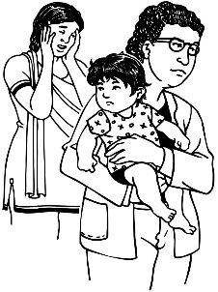
It is hard for children if people do not agree who should look after them.

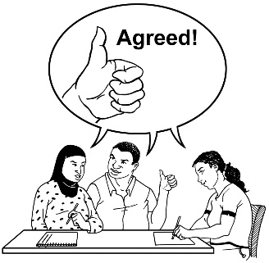
It is best if adults can agree:
- quickly

- without going to court.
There are services to help families agree.
There were big changes to these services in 2014.
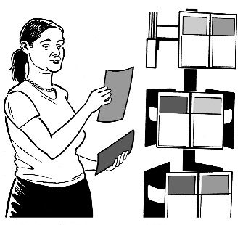
But there was not good information to help families understand the changes.

Sometimes people have to use these services before they go to the Family Court.
Even though they have no choice about using the services they still have to pay to use them.

What changed for services that support families?
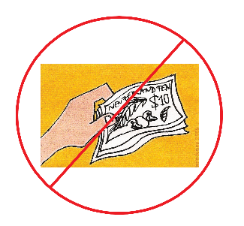
Before 2014 parents could get free counselling when they first decided to separate.
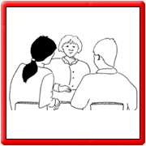
Counselling is when someone helps you to talk about:
- what is happening

- what you want to do about it.

Free counselling was stopped in 2014.

In 2014 Family Dispute Resolution was set up.

Family Dispute Resolution helps parents to agree about the care of their children.
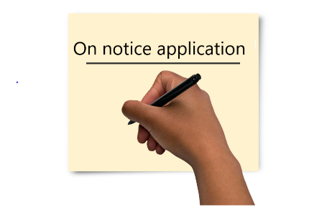
There is a rule that parents must go to Family Dispute Resolution before they make an on notice application to the Family Court.
Sometimes parents have to pay for Family Dispute Resolution.

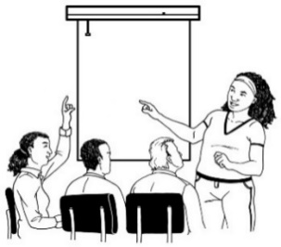
Parents must also do a Parenting Through Separation course before they make an on notice application.
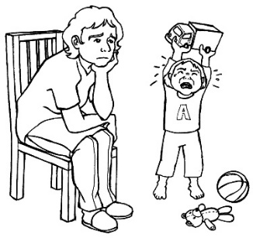
Parenting Through Separation helps parents understand what their break up might feel like for their children.
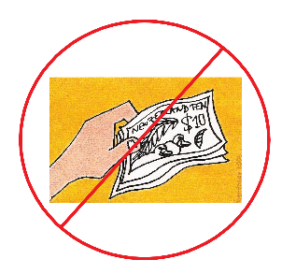
Parenting Through Separation is free.

What needs to happen for services that support families?
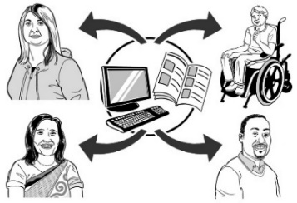
It should be easy to get information about family justice services.
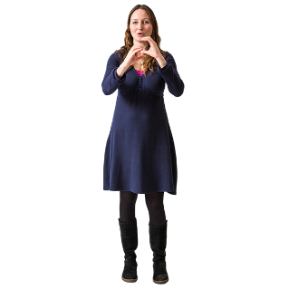
So that everyone can use this information it needs to be in a range of:
- formats like Easy Read or braille

- languages.
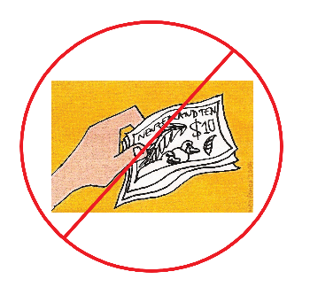
Services that help parents and whānau make decisions about who will look after children should be free.
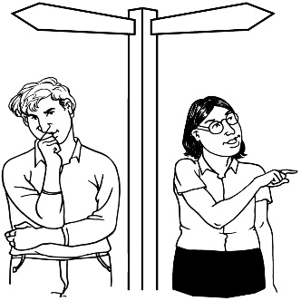
Parents and whānau should be able to use services at the time that is right for them.

Parents and whānau should not have to use these services before they go to the Family Court.
Services need to be right for the culture of the family.

Judges should be able to send parents and whānau to:
- counselling

- the Parenting Through Separation course

- Family Dispute Resolution.

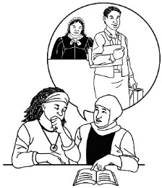
Parents and whānau should be able to get help from a lawyer early on.
They should be able to use the same lawyer for everything that happens in the Family Court.

Looking to the future
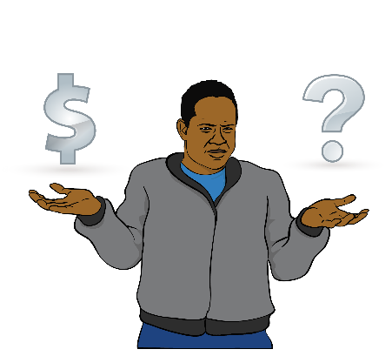
It is not only the 2014 changes that have caused problems for family justice services.
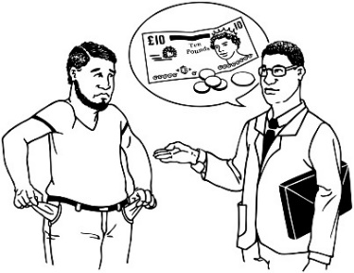
For 10 years or more there has not been enough money to run the services well.
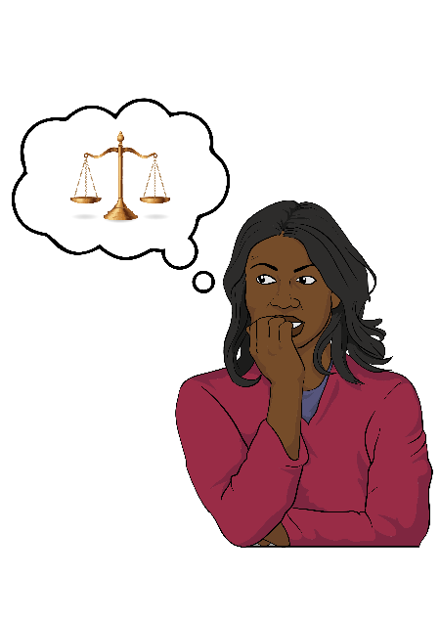
Some of the decisions about how to run these services have not been good for:
- children
- parents
- family / whānau.

To make sure that family justice services work well for everyone we need to:
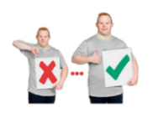
- keep looking at how well Te Korowai Ture ā-Whānau is working

- keep thinking about how to make it better.

What needs to happen in the future?
Better information needs to be collected from family justice services.

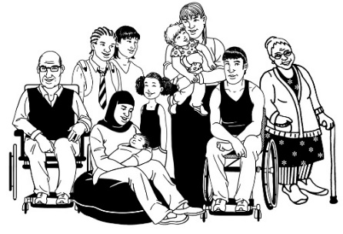
We need to collect information about:
- the people who use the services

- how many complex cases there are

- how complex cases are looked after.
To collect better information the Ministry of Justice will need money for better computer systems.

There needs to be a plan to keep checking whether services are working well.
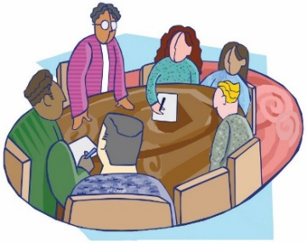
There should be groups of people who understand family justice services to give advice on changes.
There should also be a better form for people to make applications to the Family Court.

Last thoughts

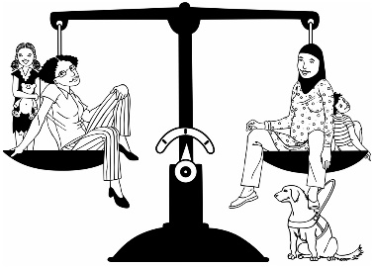
Te Korowai Ture ā-Whānau should be an example of how the justice system can work well.

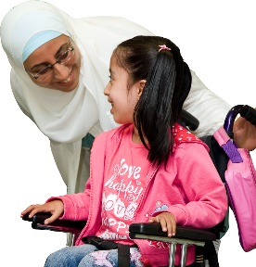
It could show other services how to:
- put children at the centre of what they do

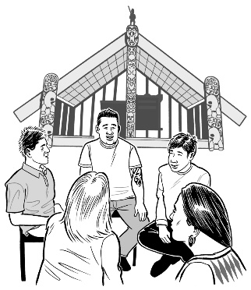
- work with disabled people to meet their needs

- make room for the Māori world and Māori ways of doing things
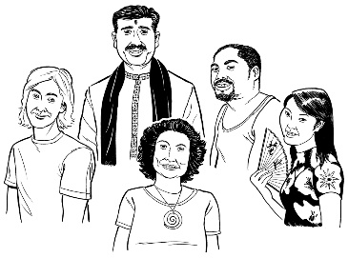
- work well with people from all different cultures
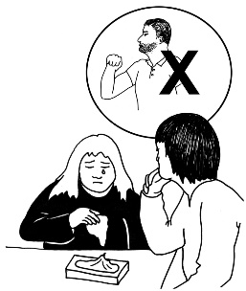
- do things well when family violence is happening.
We think all the ideas for change in this report should be used together.
This will help the Family Court get its work done on time.

In the future it is important that we:
- keep looking at how well Te Korowai Ture ā-Whānau is working
- keep thinking about how to make it better.

Most of the ideas for change in this report will not cost a lot more money.
The only idea that will cost a lot more money is the idea about having a better computer system.

To connect up our family justice services there will need to be people who lead the way:
- people working in all parts of family justice services
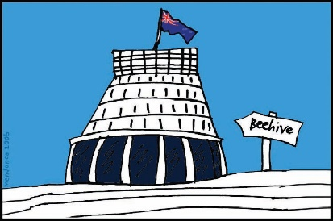
- politicians

Politicians are the people who
we vote to be in parliament.

We have found that a lot of people agree with the ideas for change in our report.
This will be helpful as we work to make family justice services better.

This information has been translated into Easy Read
by the Make It Easy service
of People First New Zealand Inc. Ngā Tāngata Tuatahi.

The ideas in this document are not the ideas of
People First New Zealand Inc. Ngā Tāngata Tuatahi.
