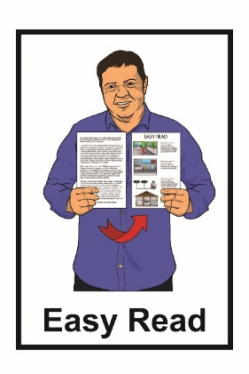

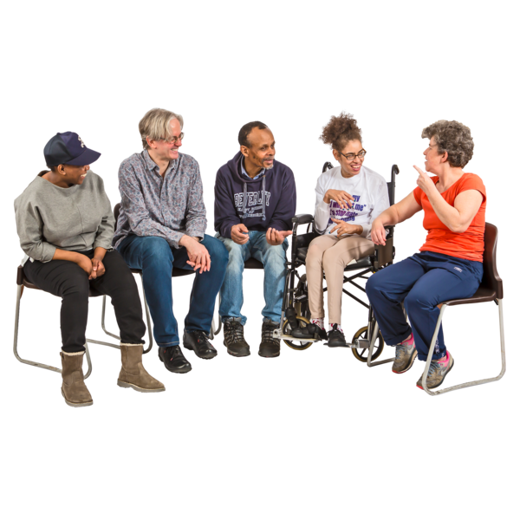

Have your say
about laws to stop hate speech

July 2021

What you will find in here

Page number:

Before you read this document 3

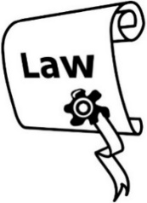
What is discrimination and
incitement of hate? 7

Royal Commission of Inquiry……...10

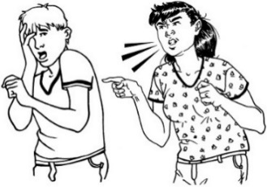
What you can do if you are experiencing incitement of hate 15

Our 6 proposals 19

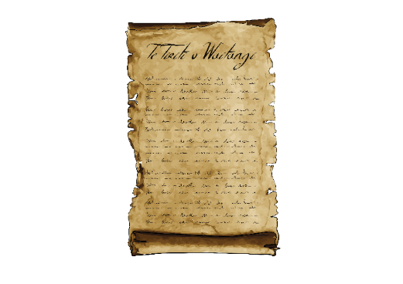
Page number:

Treaty of Waitangi 33
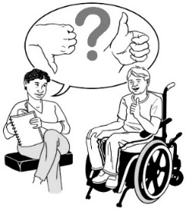

We want to know what you think 34

Where to find more information 39

Before you read this document

This document is about incitement of hate.

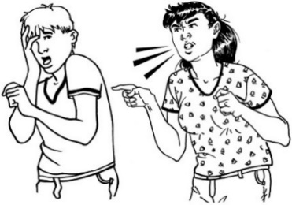
Incitement of hate can also sometimes be called hate speech.

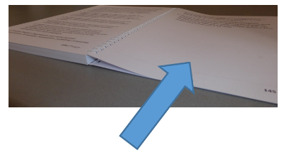
We look more closely at what incitement of hate / hate speech means on pages 7 to 9.

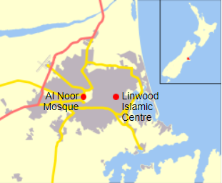
There is also some information about a serious attack that happened in Christchurch in 2019.

There are some pictures in this booklet that may upset people.

There is also some information in this booklet that may upset people when they are reading it.

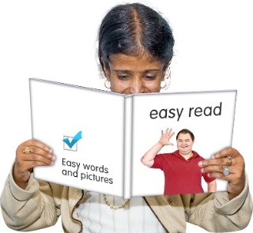
If reading this document upsets you then you may want to:
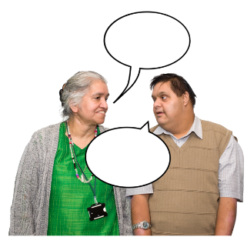
- take a break from reading it
- talk about your feelings to someone you trust
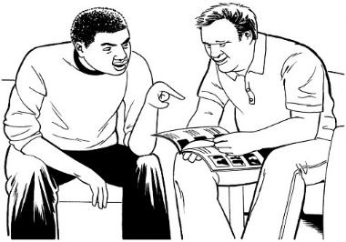
- ask a support person to read it with you
- only read a little bit at a time.

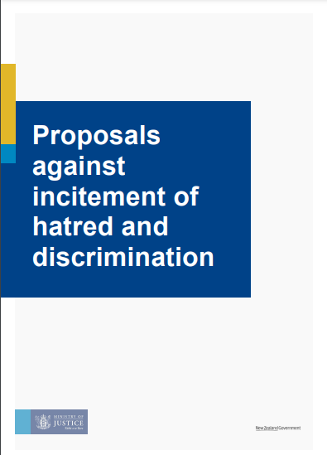
The Ministry of Justice have written a document called:

Proposals against incitement of hatred and discrimination in Aotearoa New Zealand

You can find this report on the Ministry of Justice website:

https://www.justice.govt.nz/assets/Documents/Publications/Incitement-Discussion-Document.pdf

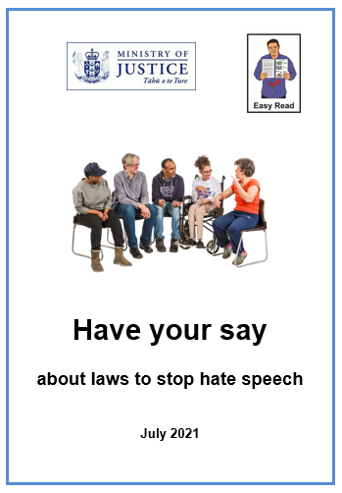
This is an Easy Read translation of the summary document.

This is a long document.

You can:

- ask someone you know to read it with you
- only read a little bit at a time.

What is discrimination and incitement of hate?

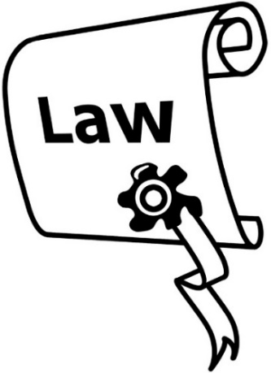
This document is about changing the law about:
- discrimination
- incitement of hate.

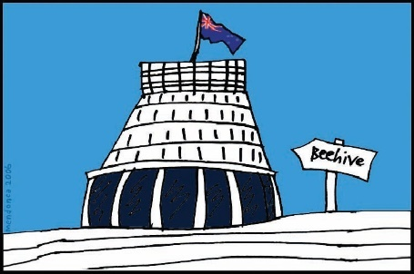
Laws are rules made by the government which people must follow.

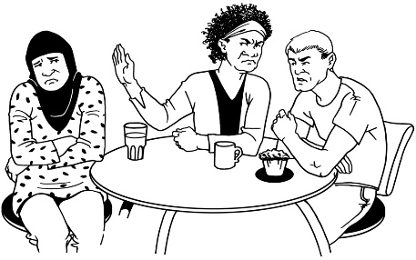
Discrimination is when people are treated unfairly because of things like their:
- religious beliefs

- disability.
Incitement of hate is when people say things in a way that stirs up hate against a group of people.

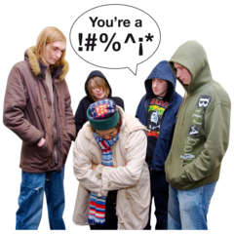
They might say things that are:

- very hurtful

- abusive
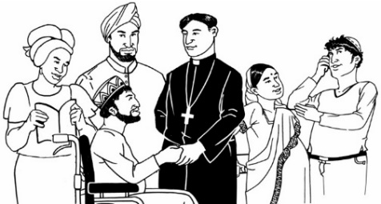
- threatening.

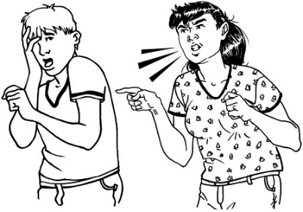

Incitement of hate can also sometimes be called hate speech.

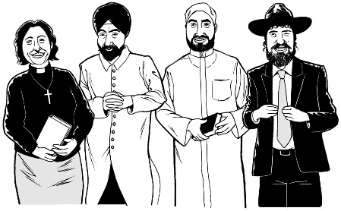
People might incite hate about a group of people because of their:
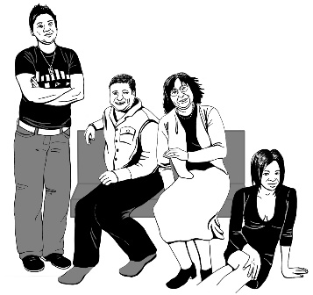
- religion
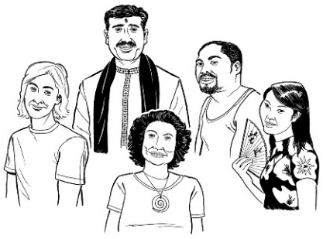
- gender which means being a man or a woman or another gender
- race or skin colour
- something else.

Royal Commission of Inquiry

On 15 March 2019 in Christchurch a terrorist attack killed 51 Muslim people in 2 mosques.

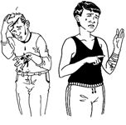
A terrorist attack is when a person or a group of people do something to hurt or kill a lot of people because of what they believe.

A mosque is a place of worship for Muslim people.

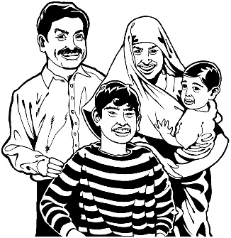
Muslim people are people who follow the religion called Islam
.

After this attack happened a Royal Commission of Inquiry into the terrorist attack on Christchurch mosques on 15 March 2019 was set up.

A Royal Commission is a group of people who come together to look at:
- something that happened
- why it happened.

In this document we will call this Commission the Royal Commission.

You can find more information about the Royal Commission on their website:

www.canterbury.royalcommission.govt.nz/What-is-a-Royal-Commission

This website is not in Easy Read.

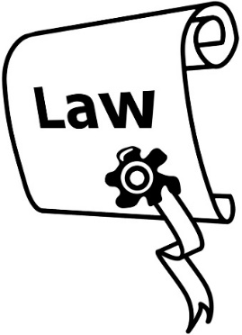
The Royal Commission found that our laws about incitement:

- are confusing

- need to be changed.

Inciting hate causes lots of harm to all of us.

It can lead to violence.

Violence is when someone or a group of people hurt another person or group of people.

It is important to make sure our laws still let people say what they think.

This does not mean people can say or do things that incite hate.

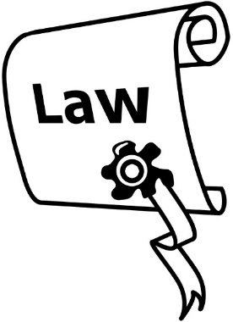
The laws about inciting hate that the government wants to change are parts of:
- The Human Rights Act 1993
- The Crimes Act 1961.
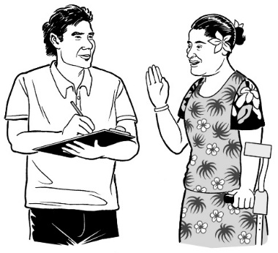

We want to know what you think about the plans to change these laws.

What you can do if you are experiencing incitement of hate

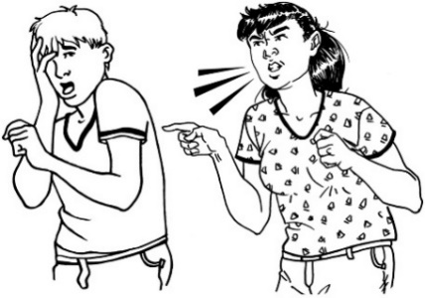
Experiencing incitement of hate means it is happening:
- to you
- near you.

You should talk to the police if you feel:
- scared
- not safe.

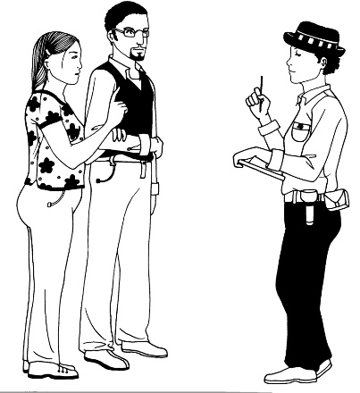
If it is an emergency you should call the police on:

111.

An emergency is when you need help:

- fast

- right now.

If it is not an emergency you can call the Police on:

105.

If you think you are being discriminated against you can talk to someone at the Human Rights Commission.

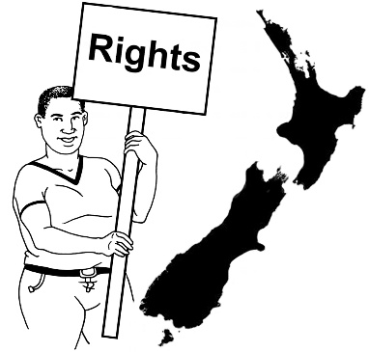
The Human Rights Commission works on making sure human rights are met for everyone.

For information about what the Human Rights Commission can do see their website at:

https://www.hrc.co.nz/enquiries-and-complaints/how-make-complaint/

If you are experiencing hate on the internet you can find support at:

https://www.netsafe.org.nz/

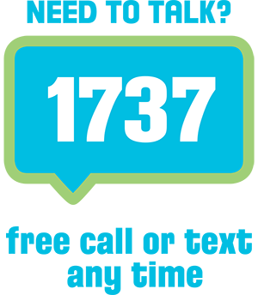
If you would like to talk about how you are feeling you can talk to someone at 1737: Need to talk.

You can do this by calling or texting:
1737.

1737: Need to talk is free.

It will not cost you any money to ring or text 1737.
1737 is open: every day all day and all night.

Our 6 proposals

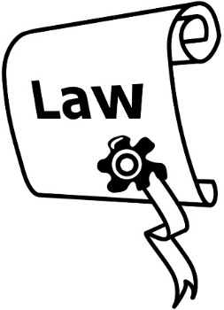
The government thinks the laws about incitement of hate need to be made clearer to keep everyone safe.

The government has made 6 proposals.

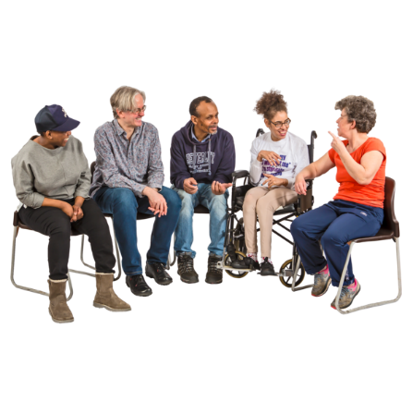
Proposals are ideas the government thinks should happen.

We want to hear what people think before the law is changed.

The proposals may change because of what people tell us.

Proposal 1
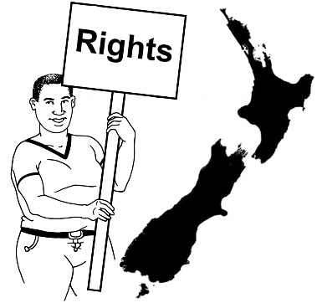

Proposal 1 is to change the incitement of hate part of the Human Rights Act.

The incitement part of the Human Rights Act is about speech that is aimed at a group because of:
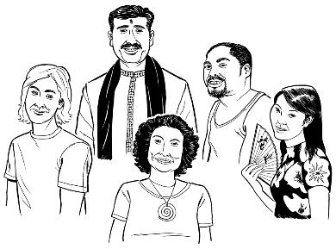
- their skin colour
- their race
- the country they are from.
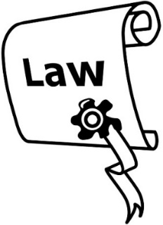
If we change this law it could mean more groups of people are added to this list.

For example it could include hate speech that is said about a group because:
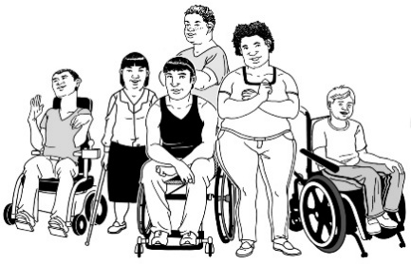
- of their gender
- they are disabled.

We want to find out which groups you think should be part of the list.

Proposal 2

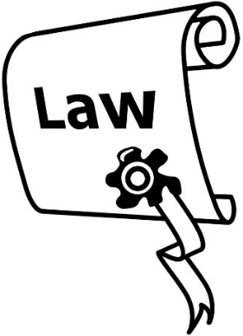
Proposal 2 is to move the part of the law that makes inciting hate a crime from the Human Rights Act to the Crimes Act.

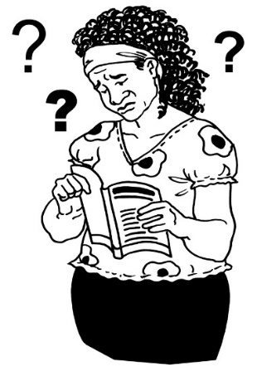
It would also change the words of this part of the law.

The words in the Human Rights Act now may be confusing.

The words in the Crimes Act would be clearer.

The new wording in the Crimes Act would mean that intentionally inciting hate would be a crime no matter how it was done including:
- by speaking
- by writing
- on the internet.

Intentionally means doing something on purpose.

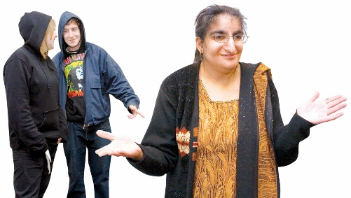
We want to make other changes so that the law also covers times when people keep inciting hate that has already started happening.

Putting the new wording in the Crimes Act would show how important it is to stop inciting hate.

Proposal 3

Proposal 3 is to make the punishment for the crime of inciting hate bigger.

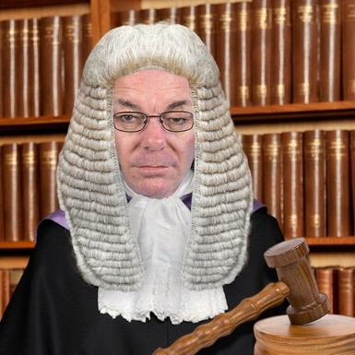
Punishment is what happens when a court decides someone has broken the law.

Punishment might mean things like:
- going to prison
- having to stay at home which is called home detention
- paying money which is called a fine.

At the moment the biggest punishment for inciting hate is:
- up to 3 months in prison
or
- a fine of up to 7 thousand dollars.

We think this could be changed to:
- up to 3 years in prison
or
- a fine of up to 50 thousand dollars.

Proposal 4

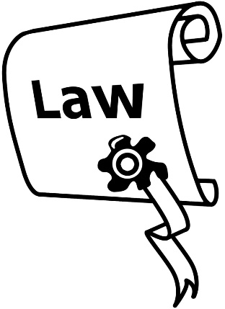
There is another part of the Human Rights Act that makes incitement against the law.

This kind of law is called civil law.
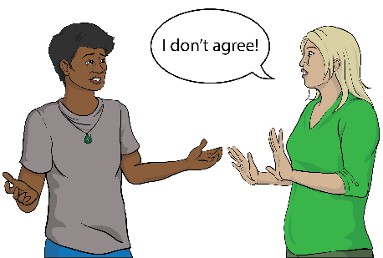

Civil law is mostly used when people or organisations cannot agree.

For example taking someone to court if they owe you money is civil law.

Civil law is different to criminal law.

Criminal law is when you are punished for doing something wrong which is called a crime.
Proposal 4 is about:

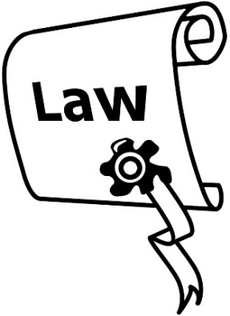
- making the part about incitement in civil law match the part in criminal law

- adding some of the same words to the civil law that are in Proposal 2 for the criminal law.

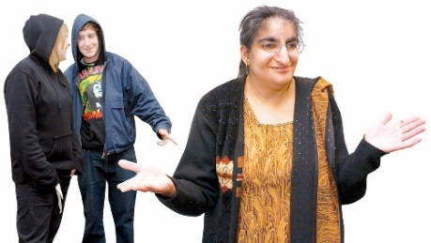
This includes the wording about hate that has already started.

If someone incited hate people could complain to the Human Rights Commission about it.

Proposal 5

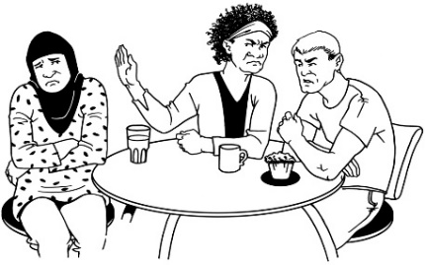
Proposal 5 is to make incitement to discriminate against the law.

Incitement to discriminate means stirring up people to discriminate.

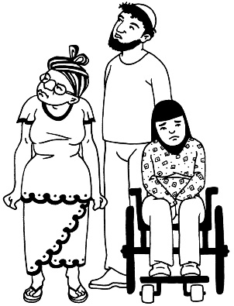
Discrimination is when people are treated unfairly because of things like their:
- religious beliefs

- disability.

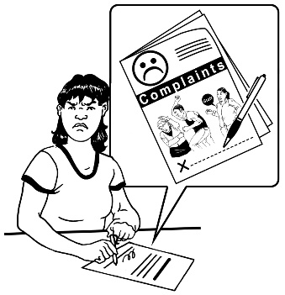
If incitement to discriminate was breaking the law it would mean people could complain to the Human Rights Commission about it.

Proposal 6

The Human Rights Act covers discrimination against a group of people because of their sex.

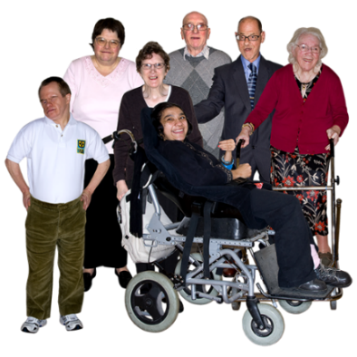
The word sex means different things to different people.

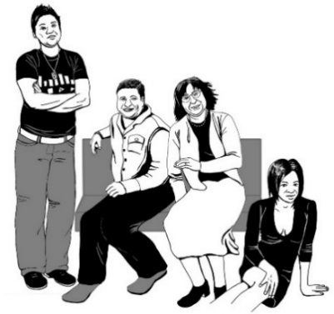
Sex could mean things like:
- if it says female or male on your birth certificate
- if you are a man or a woman or another gender.
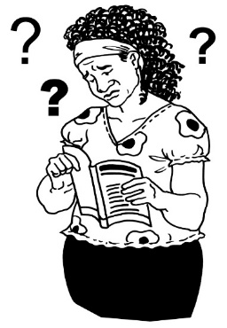

Not everyone understands this part of the law in the same way.

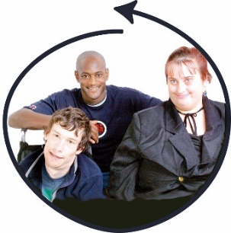
This proposal will change the Human Rights Act to make it clear that it includes:
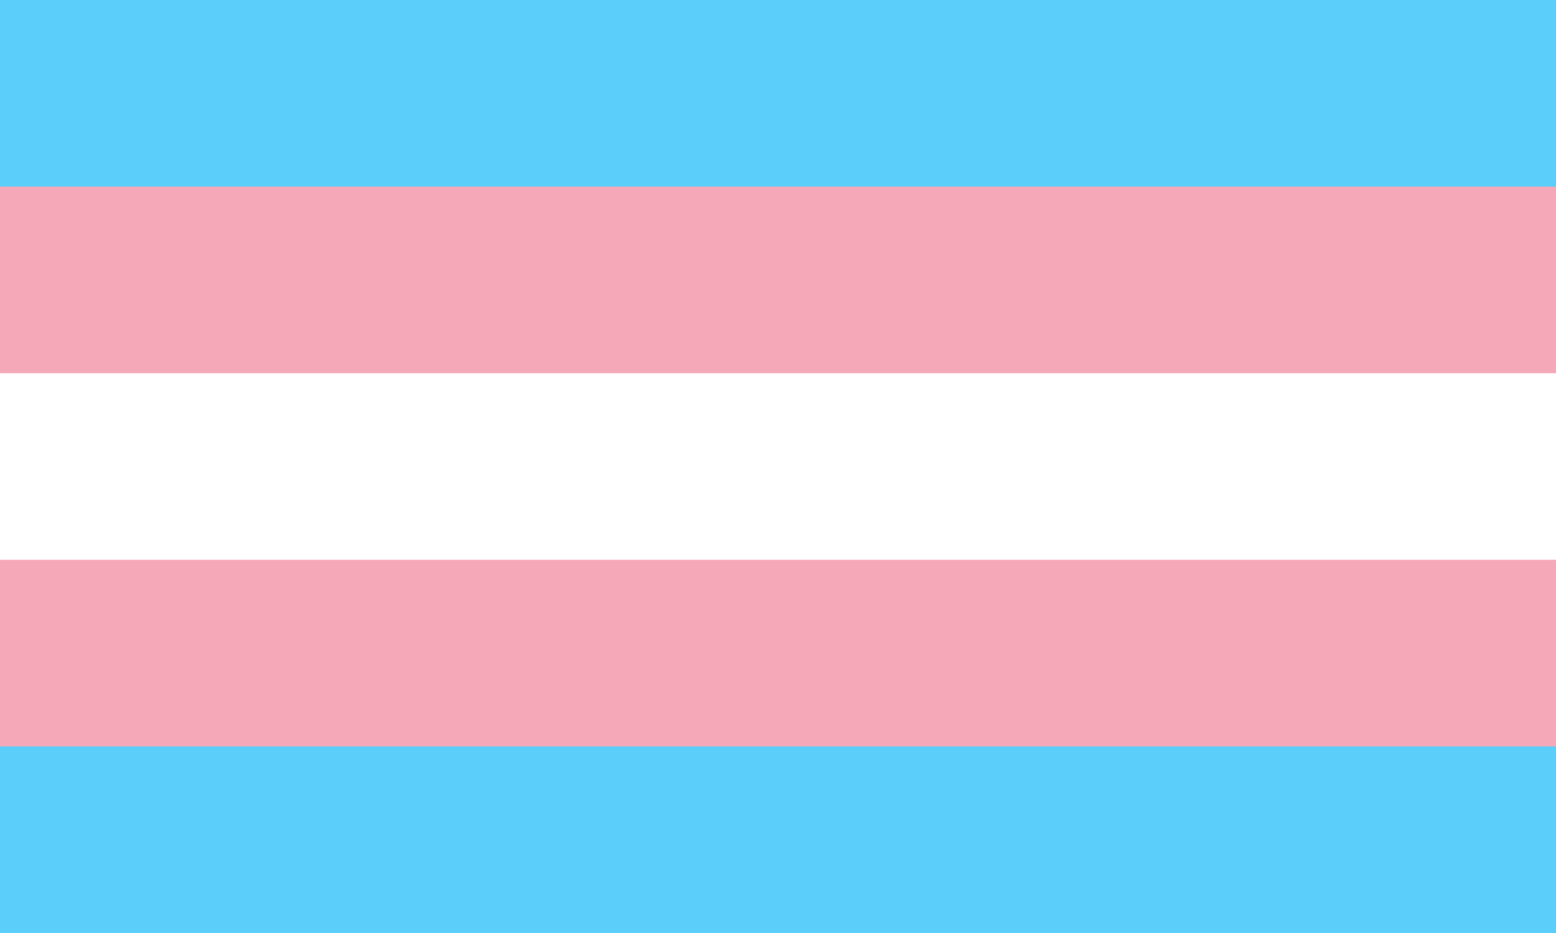
- trans people
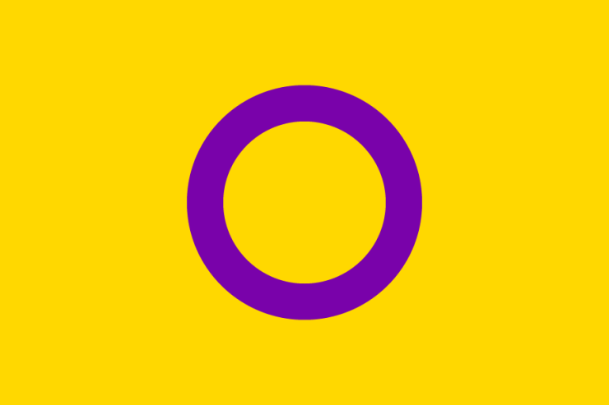
- gender diverse people
- intersex people.

Trans people are people whose gender is different to what people thought it was when they were born.

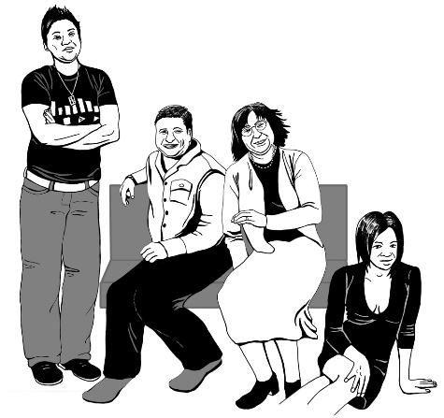
Some trans people change things to fit better with their gender like:
- changing their name
- wearing different clothes
- changing how their body is.

Gender diverse people means:
- trans people
- non-binary or genderqueer people – people who are not men or women
- people who have culturally specific genders.
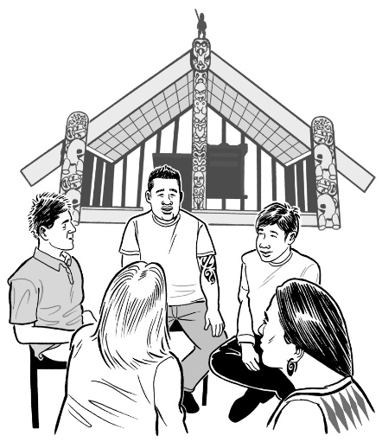

Culturally specific genders are genders only for people of one culture.

For example Māori can be takatāpui.

Intersex people are people whose bodies do not match what many people think of as female or male.

Intersex people can be any gender.
Treaty of Waitangi
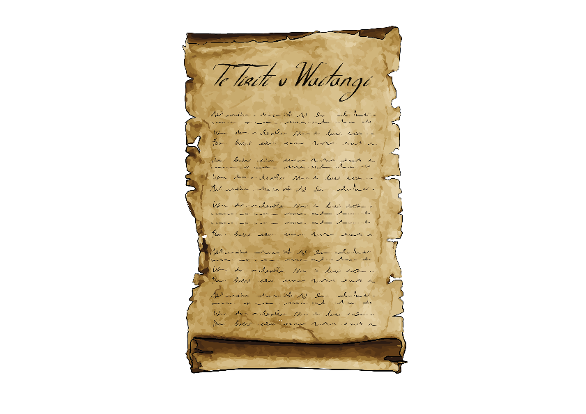

Te Tiriti o Waitangi / The Treaty of Waitangi is a legal document that was signed in 1840.

The Treaty is important to New Zealand.

It is about:
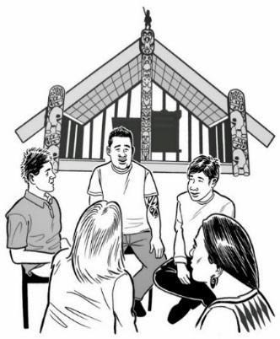
- Māori and the New Zealand Government working together
- making decisions together

- protecting things that are important to Māori.

We want to know what you think
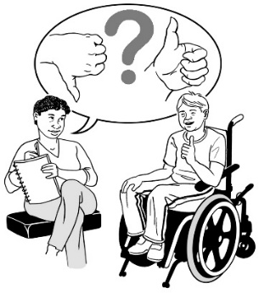

We want to know what you think about these proposals.

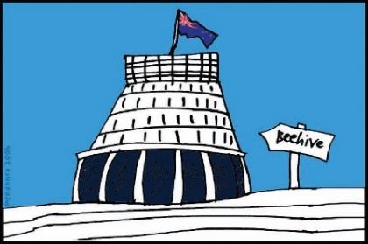
What you tell us will be used by the government when they decide what to do.

You have until 6 August 2021 to have your say about hate speech.

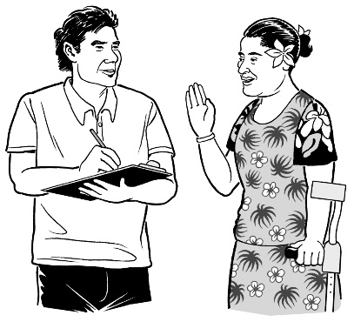
You can tell us what you think by:

- doing an online submission

- writing or emailing us your submission

Online means using the internet to do things like:

- looking at websites

- sending emails.

A submission is when you write down what you think of our proposals.

You can make an online submission using your computer.

You can do this by filling in the online submission form at:
https://consultations.justice.govt.nz/policy/incitement-of-hatred/

This online submission has lots of questions.

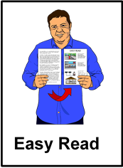
The online submission is not in Easy Read.

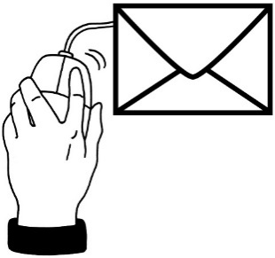
You can also send us your submission:
- by email to:
humanrights@justice.govt.nz
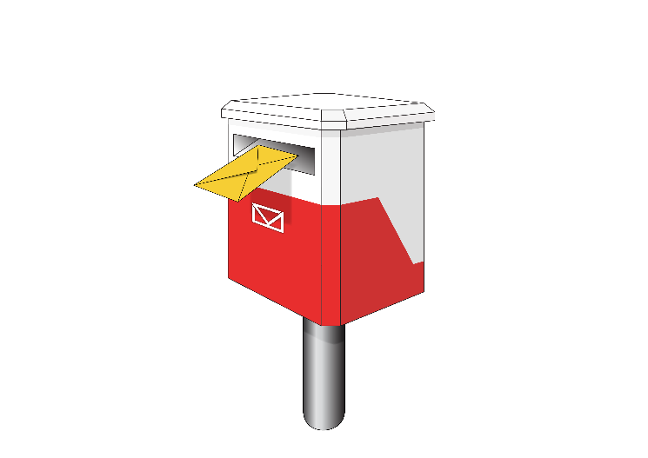
- by post to:
Human Rights

Ministry of Justice
SX10088
Wellington
If you cannot make a submission in these ways please get in touch with us using the email address or postal address on page 36.

We can support you to make a submission in a way that works for you.

Some questions to think about as part of your submission

Some questions you may want to think about when writing your submissions:
- are there ways these proposals could be made better?
- are there groups who experience incitement of hate who should be protected by these proposals?
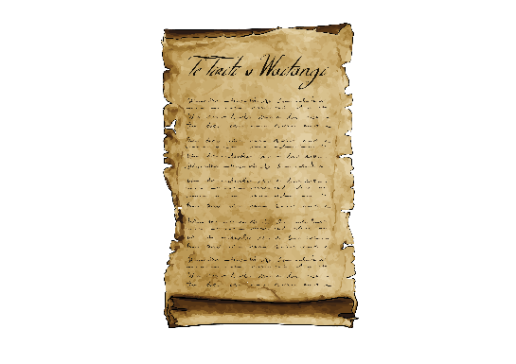
- do you see any problems that might happen because of the changes in these proposals?

- is there anything about the Treaty of Waitangi that we need to think more about?

- do you think there should be other changes?

Where to find more information

This Easy Read translation is only a short version of the Ministry of Justice discussion document.

You can find the full document at:

https://www.justice.govt.nz/proposals-against-incitement-of-hatred-and-discrimination

If you have any questions you can contact us by email at:

humanrights@justice.govt.nz

This information has been written by the Ministry of Justice.

It has been translated into Easy Read by the Make It Easy service of People First New Zealand Inc. Ngā Tāngata Tuatahi.

The ideas in this document are not the ideas of People First New Zealand Inc. Ngā Tāngata Tuatahi.
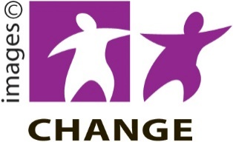

Make It Easy uses images from:

- Changepeople.org

- Photosymbols.com
- Sam Corliss.

All images used in this Easy Read document are subject to copyright rules and cannot be used without permission.

