Survey about the
Family justice system
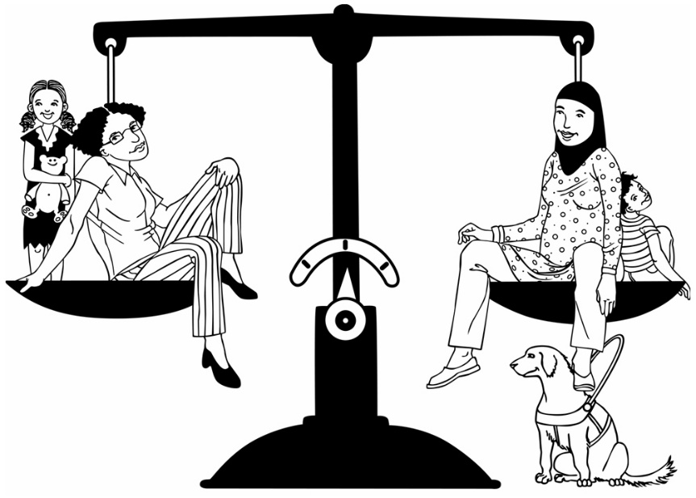

Have your say
January 2019

What is in this book?

Page Number
Before you start 4
How to use this survey 5
What is the Family Justice System? 7
What is the Independent Panel? 8
What is in this book?
Page Number
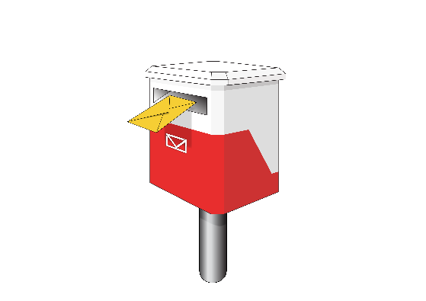
Ways to give your feedback to us 15
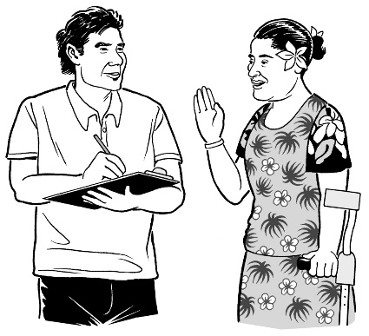
Making the family justice system
stronger 18
Survey questions 26

What is in this book?
Page Number
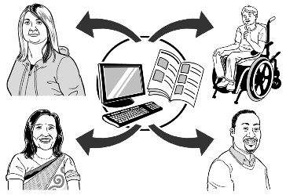
Important things you need to know about your submission 64
Questions about you 73
Thank you 82

Before you start

This is a long document.

While it is written in Easy Read it can be hard for some people to read a document this long.

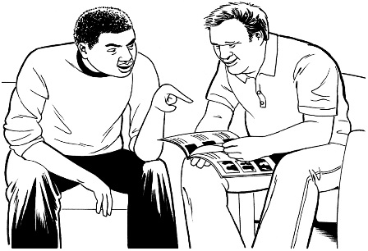
Some things you can do to make it easier are:
- read it a few pages at a time

- have someone help you to understand it.

How to use this survey
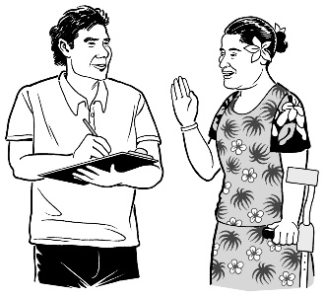
This is the Easy Read version of Have your say: January 2019 family justice system changes survey.

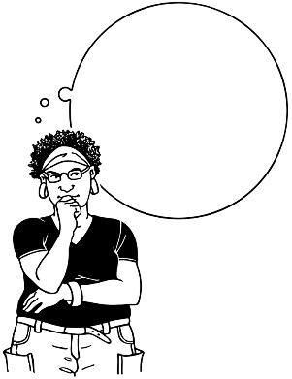
In this survey there are:

- ideas on how to make the family justice system better

- questions about how you think we can make the family justice system better.

If you want to read the version of this survey that is not in Easy Read you can use this website:

https://www.justice.govt.nz/assets/Documents/Publications/Strengthening-the-family-justice-system.pdf

You might need support to read this version of the survey.

What is the family justice system?

The family justice system helps families to work out the best way to care for their children when parents are not living together.

The Family Justice System includes things like:
- services that help people
- the family court.

What is the Independent Panel?
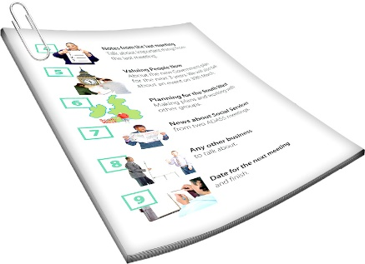
This survey has been made by an Independent Panel.

The Independent Panel is a group of 3 people.
The people on the Independent Panel know a lot about the family justice system.
This document was written by:
- Rosslyn Noonan
- Chris Dellabarca
- La-Verne King.

Rosslyn Noonan is the Chairperson of the Independent Panel.
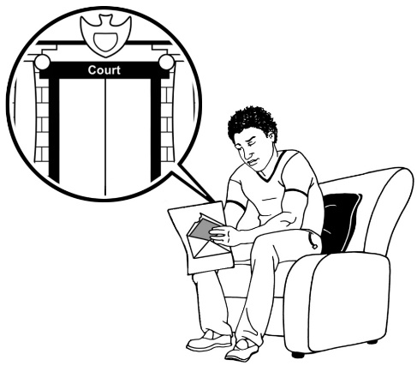
A letter to you from the Independent Panel

In 2014 some changes were made to the family justice system.

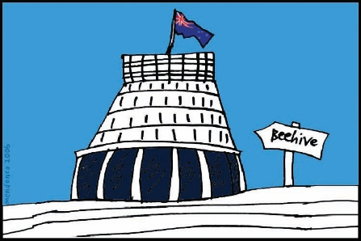
The Minister of Justice has asked the Independent Panel to talk to people who have used the family justice system since 2014.

We need to report back to him about what we find.
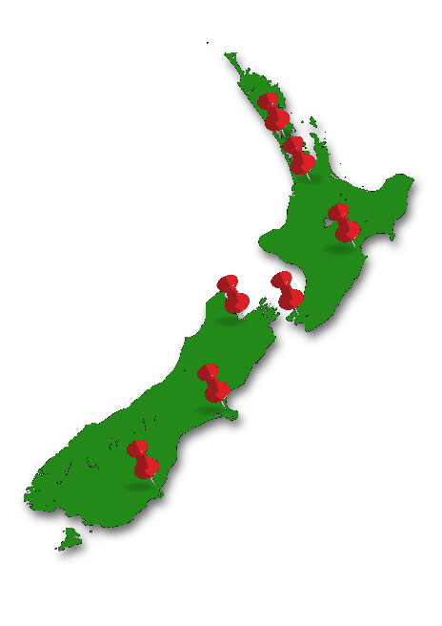

In 2018 we asked New Zealand what people thought about the changes.

The Independent Panel asked people:
- what is good about the family justice system?
- what is not good about the family justice system?
- what to do to make the family justice system better?

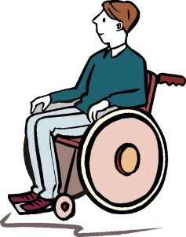
We have had meetings around the country with:
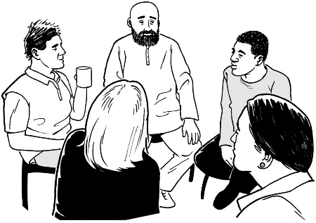
- people 1 at a time
- groups of people.

More than 500 submissions have been given to the Independent Panel.

Submissions tell us what people think about the family justice system.

If you want to read the submissions that we got you can use this website:

https://www.justice.govt.nz/assets/Documents/Publications/Family-Court-Rewrite-Summary-of-Submissions.pdf
The submissions are not written in Easy Read.

You might need support to read them.
The Independent Panel has looked at what people have told us.

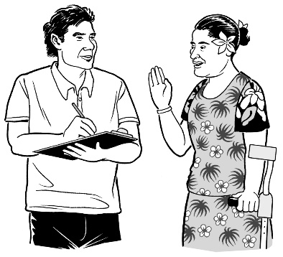
Now we are doing this survey to get more feedback.

Feedback is telling us what you think about the changes to the family justice system

Giving us feedback on the family justice system is important.

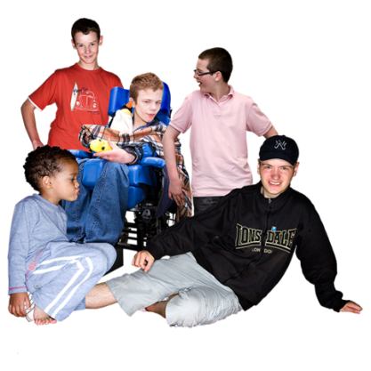
This is because it will help make the family justice system better for children.

Thank you for:
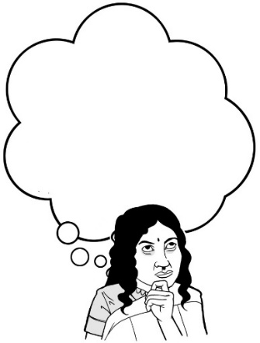
- reading this document
- answering our questions about the family justice system

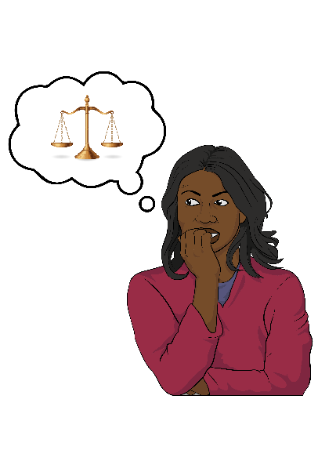
We know that answering some of our questions will be a hard thing to do.

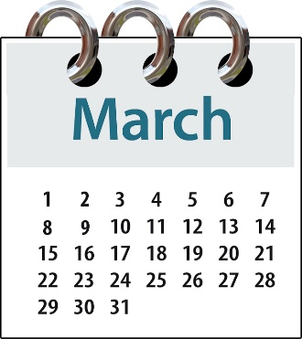
You need to send us this survey back by 1 March 2019.

We will think about all the things people have told us when we make our report for the Minister of Justice.

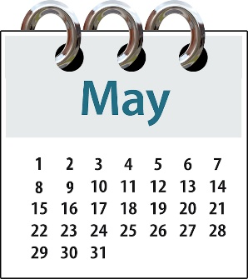
Our report has to be ready for the Minister of Justice by the end of May 2019.

Ways to give your feedback to us

You can give your feedback to us in different ways.
- You can give feedback online through our website.

Use this website address below to fill out a submission form on our website:

https://consultations.justice.govt.nz/policy/strengthening-the-family-justice-system/

The online form is not in
Easy Read.

You might need help from a person you trust to help you fill out our online submission form.

- You can email your feedback to us at:

familyjusticereforms@justice.govt.nz

- You can post us your feedback.

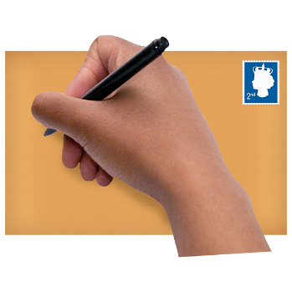
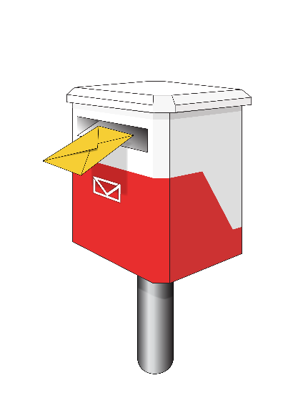
If you would like to post us your feedback please send it in an envelope to the address below:

Family Justice Reforms
SX10088
Wellington 6011
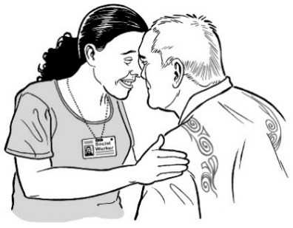
There is a Te Reo Māori version of this document at this website below:

https://www.justice.govt.nz/assets/Documents/Publications/Strengthening-the-family-justice-system-Te-reo.pdf

It is not in Easy Read.

If you have questions about:

- this document

- the Independent Panel and the work they do

send an email to:
FamilyJusticeReforms@justice.govt.nz

Making family justice services stronger
Case for change
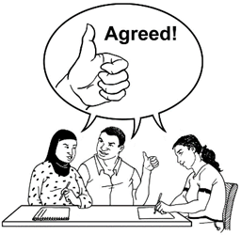

The Independent Panel thinks it is better for children if people can agree on their care without going to court.

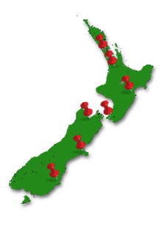

Lots of people across New Zealand think things can be done to make the family court services better.

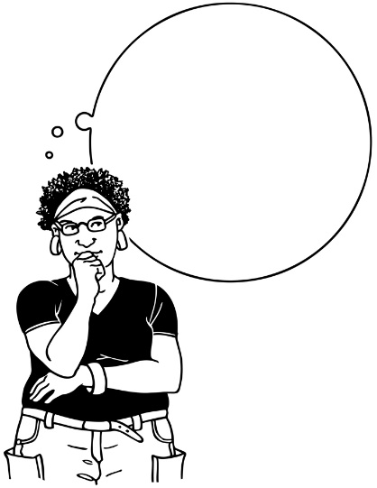
Some people think there are barriers that stop the family court services from being:

- fast
- fair

- good at making long term resolutions to disputes.

A resolution means a way to sort out a disagreement or an argument.

A dispute means a disagreement or an argument.

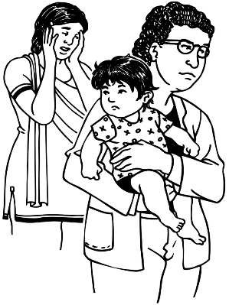
There are some things that do not make it easy to help parents who are not living together.

We call these things barriers.

The barriers are because of:

- the changes that were made to the family justice system in 2014
- some things the Ministry of Justice is doing
- complex cases - this means there are things that are part of the case that make it hard to work out what to do to make it better.

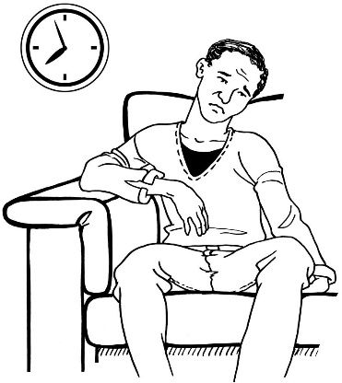
Here are some of the problems with the family court services:

- it takes a long time

- what children want to say is not heard
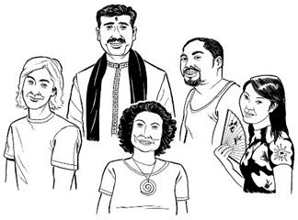
- services fit only 1 culture

- services fit only 1 kind of family

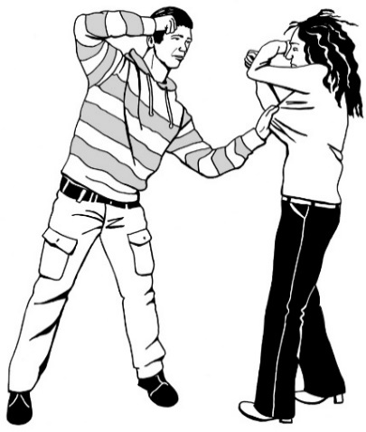
- services need to be better at helping children and families through family violence

Family violence means when somebody is hurt by another person or people in their family.

Another problem is there is not enough good information that is easy to find and use.

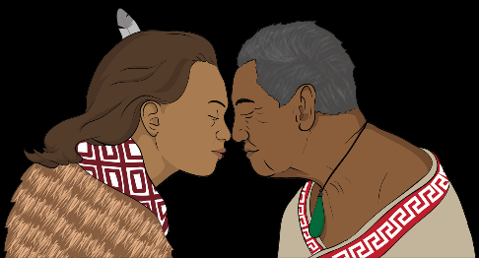
Korowai of the family justice service

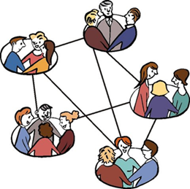
The Independent Panel thinks the family court and services should work together better so all families can get access to what they need.

We think the family court and services should be like a korowai or cloak for:
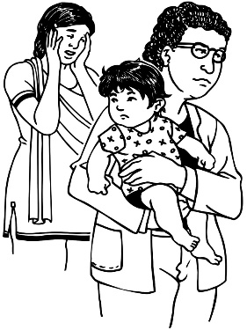
- parents that are not living together anymore
- caregivers
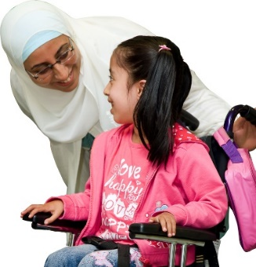
- whānau who need help to make decisions about their children.

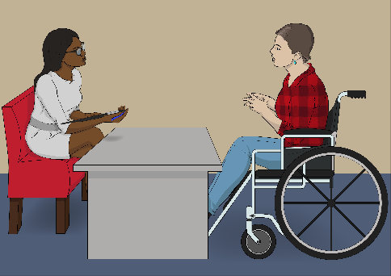
The Independent Panel want it to be easy for people to get the right family justice service in the right way at the right time.

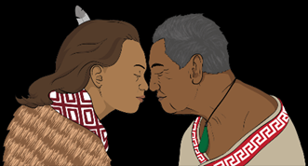
The korowai of the family justice service will make sure people get:
- good information
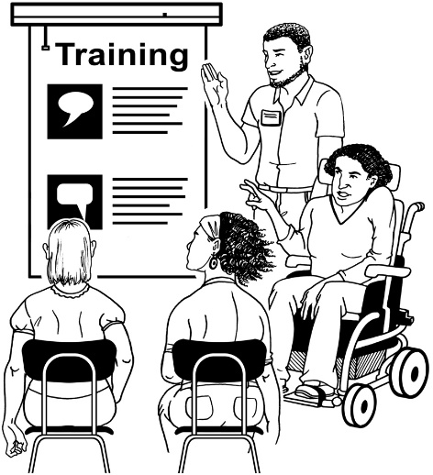
- links to community services
- the right counselling and therapeutic intervention
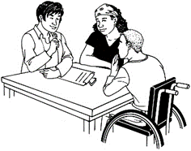
- to go on Parenting Through Separation programmes
- Family Dispute Resolution

The korowai of the Family Justice Service will also make sure people get:
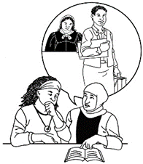
- legal advice and representation at any time
- children and young people saying what they think

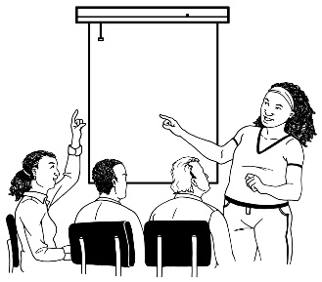
- children and young people being heard
- to apply to the family court at any time
- help from a family justice services coordinator
- help from a senior family court registrar
- to use easier court processes.

Survey questions

Child safety and wellbeing
The most important thing under the Care of Children law is to make sure children are safe and well.

- What do you think we need to check to make sure children are safe and well?

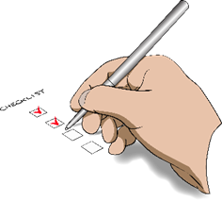
- What information should be given to the court to check children are safe and well?

When should courts get this information?

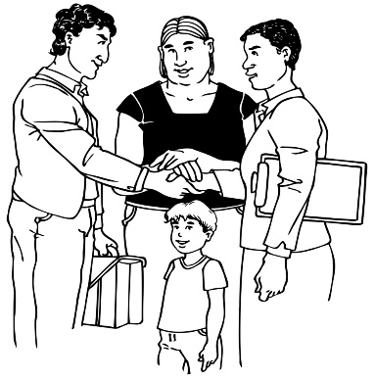
- What work should family violence workers do in the family court?

Should there be:

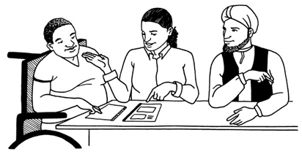
- family violence workers just for children?
- family violence workers just for adults?

Is there anything else you want to say about child safety and wellbeing?

Te Ao Māori in the family court
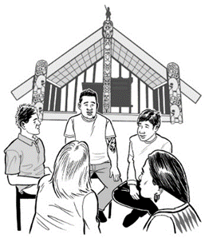
We have looked at what effect the family justice service has on the safety and wellbeing of:
- Māori children / tamariki
and
- young people / rangatahi.

- Should the Ministry of Justice and Government do things to make things better for Māori in the family court?

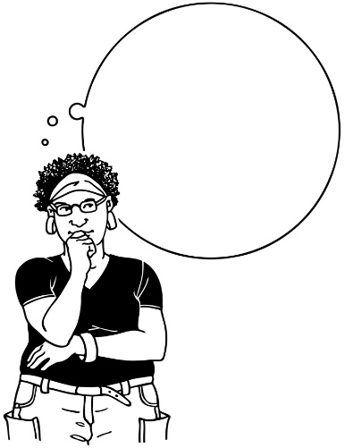

What kinds of things should the Ministry of Justice and Government do to make things better for Māori in the family court?

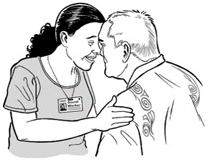
- What can the Ministry of Justice and Government do to work with hapū, iwi or Māori organisations to make a better family justice service for Māori?

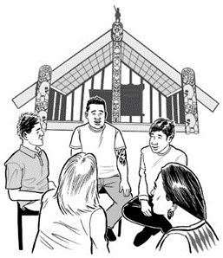
- How can tikanga Māori / Māori customs and values be included in family court?

- Is there anything else you want to say about how to make the family justice service better for Māori?

Good information that is easy
to find and use
Lots of people in New Zealand do not know about:

- the family justice system

- family justice services

- how to find family justice services

- how to use family justice services.

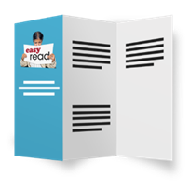
- What information will help make the family justice service easier to find and use?

Counselling and therapeutic intervention

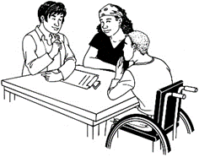
Counselling means someone can get support and advice on what to do about:
- their problems

- what they are worried about.

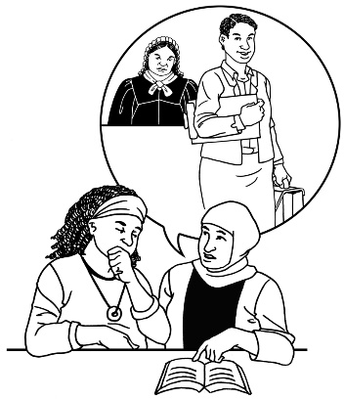
Counselling before going to Court was stopped in 2014.

Before 2014 it was normal to go to counselling before going to court.

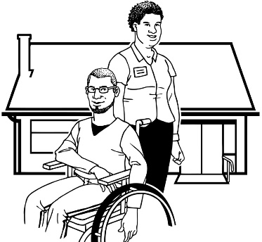
Therapeutic intervention means when things are done to help someone feel better in their mind.

- What counselling services should be available in the family justice system?

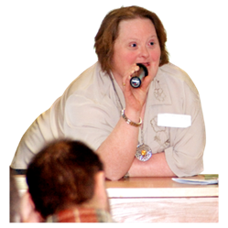
- What is the best way for people to be told how to get counselling?

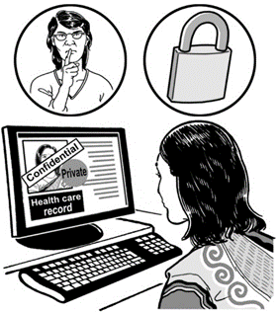
- Should it be kept secret when someone is told by the court to get therapeutic intervention?

Therapeutic intervention means when things are done to help someone feel better in their mind.

Parenting Through Separation
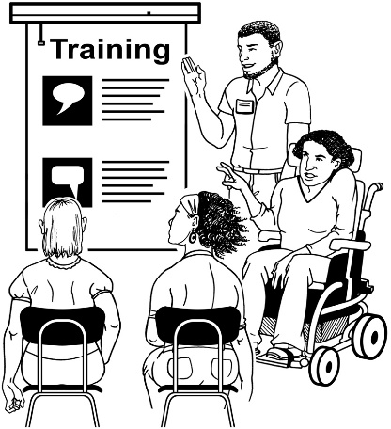
Parenting Through Separation is a free course for parents who are not together anymore.

It helps parents understand how their separation affects their children.
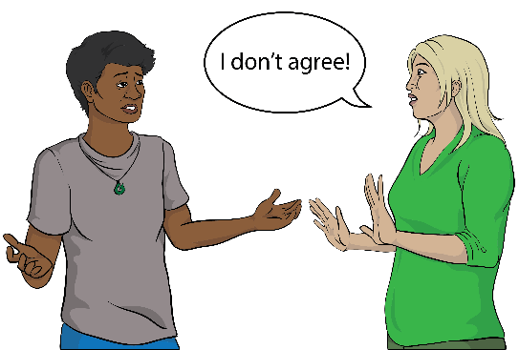

Separation means when 2 parents:
- stop living together
- stop being together
- get divorced: this means stop being married.

Lots of people think Parenting Through Separation is a good thing.

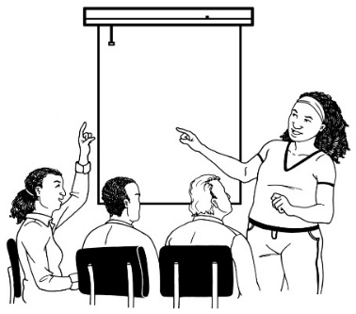
- Do you think everyone should have to do the Parenting Through Separation course?

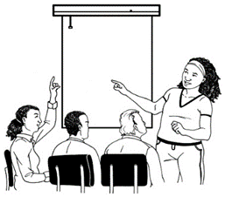
- What is the best way to ask people to go to the Parenting by Separation course?

Family Dispute Resolution
Family Dispute Resolution helps parents that are not living together anymore to agree about the care of their children.

- Should people be able to use Family Dispute Resolution whenever they need to?

- Should people that work in the family justice service tell people about why it is good to use Family Dispute Resolution services more often?

- What should be done to make the Family Dispute Resolution Service easy to use?

Legal advice and representation

A lawyer is a person who knows about the law.

Legal advice and representation means a lawyer helps a person.

In 2014 people could not get legal advice and representation in some parts of out of court processes.

Out of court processes are things that do not happen inside a court room.

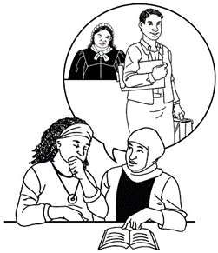
- Should people be able to get advice from a lawyer to stop arguments out of the court room?

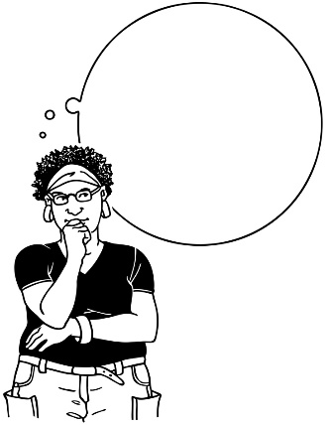

What needs to be done to make this a good service?

Case tracks and conferences

Case tracks and conferences are things that are supposed to make in court processes:

- well organised
- fast.
In court processes are things that happen inside a court room.

- What can be done to make in court processes better?

Without notice applications

Without notice applications are important in the family court process because they make sure people get help quickly when they need it.

- Do you think people will need to do less of these kinds of applications if they can get:
- advice about the law
- a lawyer to work for their case?

- Would it be a good idea to make sure people know that parenting orders made without notice can be cancelled?

Triaging
Triaging means we work out what are the best things to do next for each person that goes to family court.

- What is the best way to make sure we work out what are the best things to do next for each person that goes to family court?

Complex cases
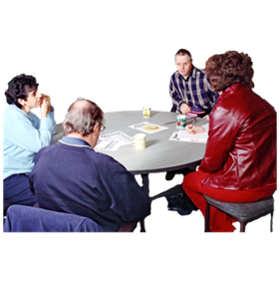
A complex case has many things that make it hard to work out what to do to make things better.

The Independent Panel has heard that some complex cases are hard to fix.

- What can be done to help judges fix complex cases?

- What therapeutic intervention would be good to use in complex cases?

Therapeutic intervention means when things are done to help someone feel better in their mind.

Cultural information in court

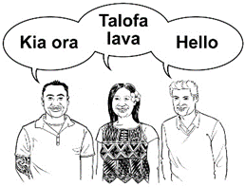
The Law says a court can get information about a child’s culture.

Cultural reports can be asked for by a judge to help the judge make a decision.

- How can we get lawyers and judges to use cultural reports?

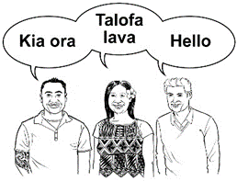
- Would it be better to get someone to come and talk to the court about a child’s cultural background than getting a written cultural report?

- Do you have anything else to say about how the court can get cultural information in a better way?

Family justice services coordinator
The work a family justice services coordinator does has changed over the years.

- Would it be a good idea to have a person work as a family justice services coordinator to help make sure people get connected to the service they need?

Senior family court registrar
We want to make sure people do not have to wait a very long time to get the family justice service they need.

We think having a senior family court registrar will help this.

- Do you think it is a good idea to have a person work as a senior family court registrar so people do not have to wait a long time to get the service they need?

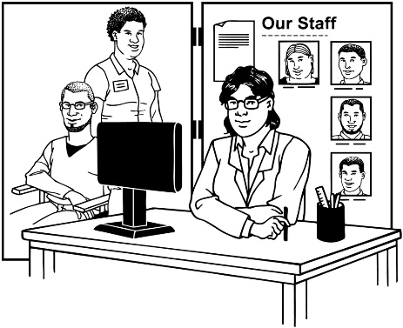
- What should the senior family court registrar be allowed to do to make things happen faster in the justice system process?

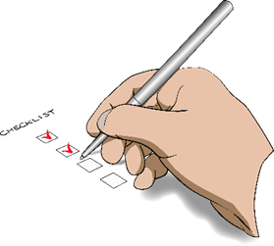
- What experience would someone need to make them be a good senior family court registrar?

Lawyer for Child
A child can only get a lawyer to help them if the court is worried about the safety and wellbeing of the child.

- Do you agree there should be a checklist to make sure a child gets the best lawyer for them?

- What experience would someone need to make them be a good lawyer for a child?

- Should someone that knows about how children think work with the lawyer to make sure children can say what they want to the judge?

Psychological reports
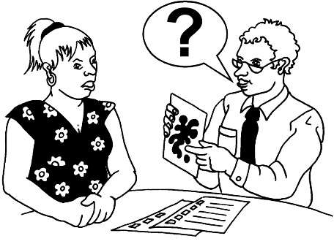
Psychological reports are reports that give more information about a person and what they think.

When a report like this is done people can ask for a second opinion report.
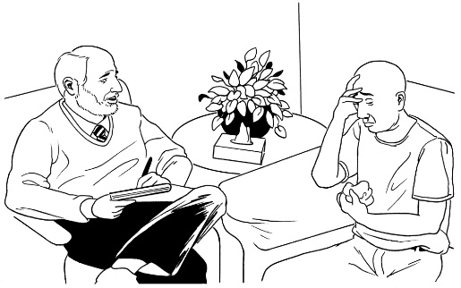

A second opinion report means a psychological report done by a different person.

- Do we need to give people more information about second opinion reports and what they mean?

- What can be done to make the process to get reports better?

- When is the best time to get a psychological report done?

- Do you have anything else to say about psychological reports?

Costs
People that use a family justice service have to pay for some of the services.

- Do you agree the judge can ask people to pay money for these services based on how they acted in their court case?

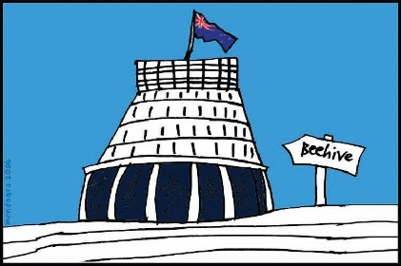
- Should Family Dispute Resolution be paid for by the Government?

Should Family Dispute Resolution be free for everyone or only for some people?

Important things you need to know about your submission

What happens to your submission?
Your submission means your answers to the questions on this form.

Your submission will be used by the Independent Panel to help us write our report to the Minister of Justice.

The Independent Panel will only share your submission with the Ministry of Justice.

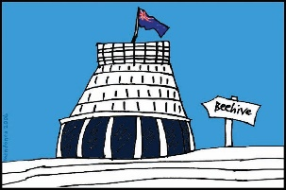
The Official Information Act says that people can ask to see information that the Government or a government agency has.

Your submission will become official information if you send it to us.

Official information is information that:
- the Government has
- a government agency has.
This means that somebody could ask for a copy of it under the Official Information Act.

If somebody asks to see your information they will not see your:
- name
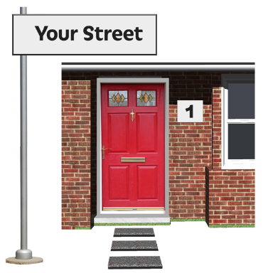
- email address
- address
- other personal information about you.

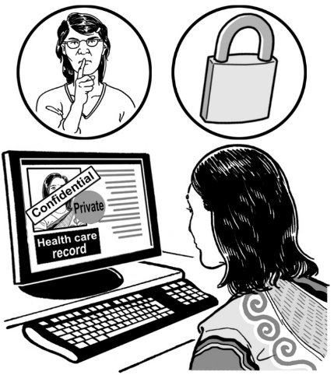
It is important you tell us:
- about information in your submission that you do not want other people to see
- why you do not want this information shared.
Court information
When you are answering these questions please do not:

- share documents about your family court case
- things about your case:
Things like:
- case numbers
- court documents.

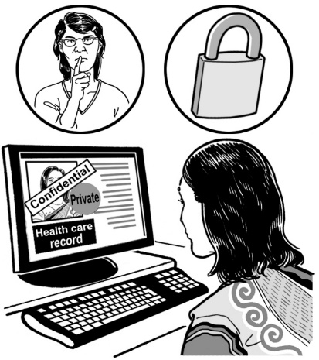
This is to protect the privacy of the people that are part of your case.

It is important your submission does not say private information about you or others.
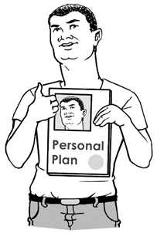
Private information is anything about a person that makes it easy to know who a person is.

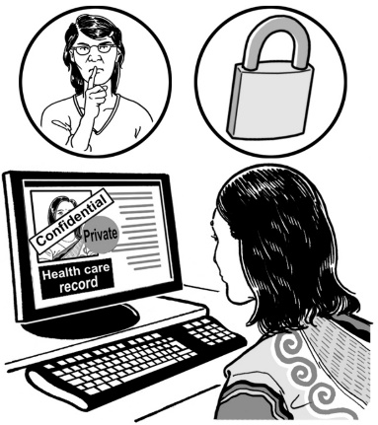
Privacy

Collecting your personal information
The Ministry of Justice will:
- keep your information safe
- only use your personal information to support the Independent Panel to make their report about the changes to the family justice system.
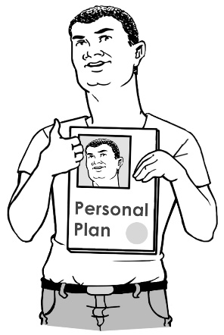

The Ministry of Justice will only get personal information about you that you choose to share.

You can choose not to share your personal email address when you give the Ministry of Justice your submission.

You can read information about the Ministry of Justice’s privacy policy.
Please visit this website below:
https://consultations.justice.govt.nz/privacy_policy

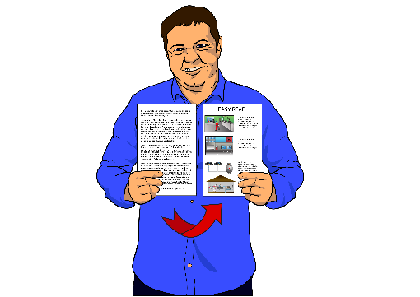
This information is not in Easy Read.

Information about you
You can ask to see any information the Ministry of Justice has about you at any time.

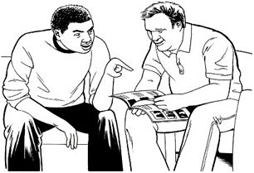
You can ask the Ministry of Justice to make changes to the information they have about you.

To see the information the Ministry of Justice has about you:
send an email to: privacy@justice.govt.nz

or
phone: 04 918 8800

or

send a letter to:
Privacy Officer
Ministry of Justice
PO Box 180
Wellington

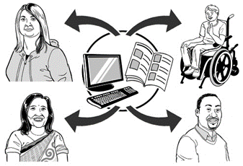
The Ministry of Justice will not share your information with anyone else unless:
- you gave your information to the Ministry of Justice so they can share it with someone else
- you said it is OK for the Ministry of Justice to share your information with someone else
- the law says your information has to be shared with someone else.

Questions about you

On the next few pages are some questions about you.
Only answer the questions you want to answer.

What is your name?

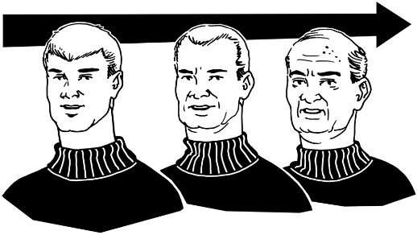
How old are you?

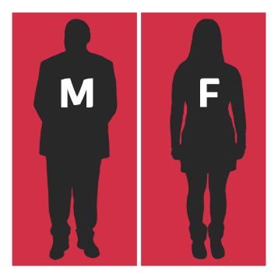
What is your gender?
Male

Female

Other

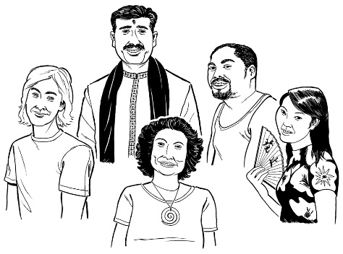
What is your culture?

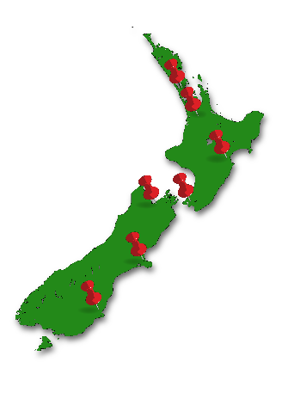
What area of New Zealand do you live in?

What services have you used?

Parenting Through separation
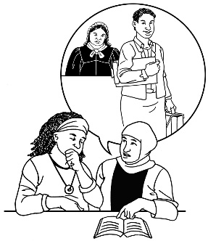

Family Legal Advice service

Family Dispute Resolution
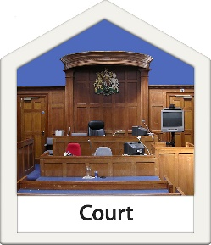

Family Court

Lawyer for the child

a lawyer.

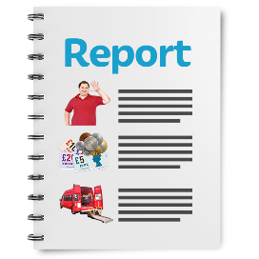
Please say what other Family Justice system services you have used:

specialist report writer

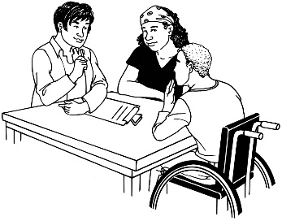
counsellor

something else.

Please tell us any other family justice services you have used:

How were you related to the child or children in the family dispute?

parent
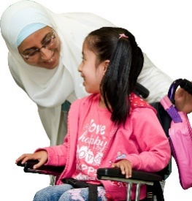

guardian

grandparent
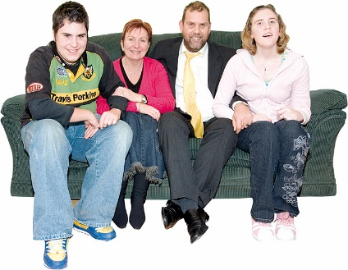

whānau / family

In some other way.

Please say in what other way you were related:

Do you work for the family justice service?
No I do not work for the family justice service

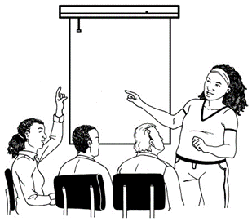
Yes I do work for the family justice service:
I work for Parenting Through Separation
I work for a Family Legal Advice Service

I work for Family Dispute Resolution

I am a Specialist report writer
I am a lawyer for a child

I am a lawyer for adults

I am a Counsellor

I work for the family court

I work as something else for the family justice service.
Please say what your job is in the family justice service:

Thank you
Thank you for taking the time to read and answer questions about the March 2019 changes to the family justice system.

Your feedback is important to us.

This information has been translated into Easy Read by the Make It Easy service of People First New Zealand Inc. Ngā Tāngata Tuatahi.
The ideas in this document are not the ideas of People First New Zealand Ngā Tāngata Tuatahi.

