**PARKING**

1 – Ronwood Ave Car park $8 per day

2 – Next to police station $7 per day

3 – Karina Williams Way (Behind Court Building) *Retain 4 Digit Code*

4 – Rainbows End public parking $7 per day (Pay and Display**)”NOT** **AVAILABLE ON SCHOOL HOLIDAY.”**

5 – Life South Church Carpark $4 per day (parkable)

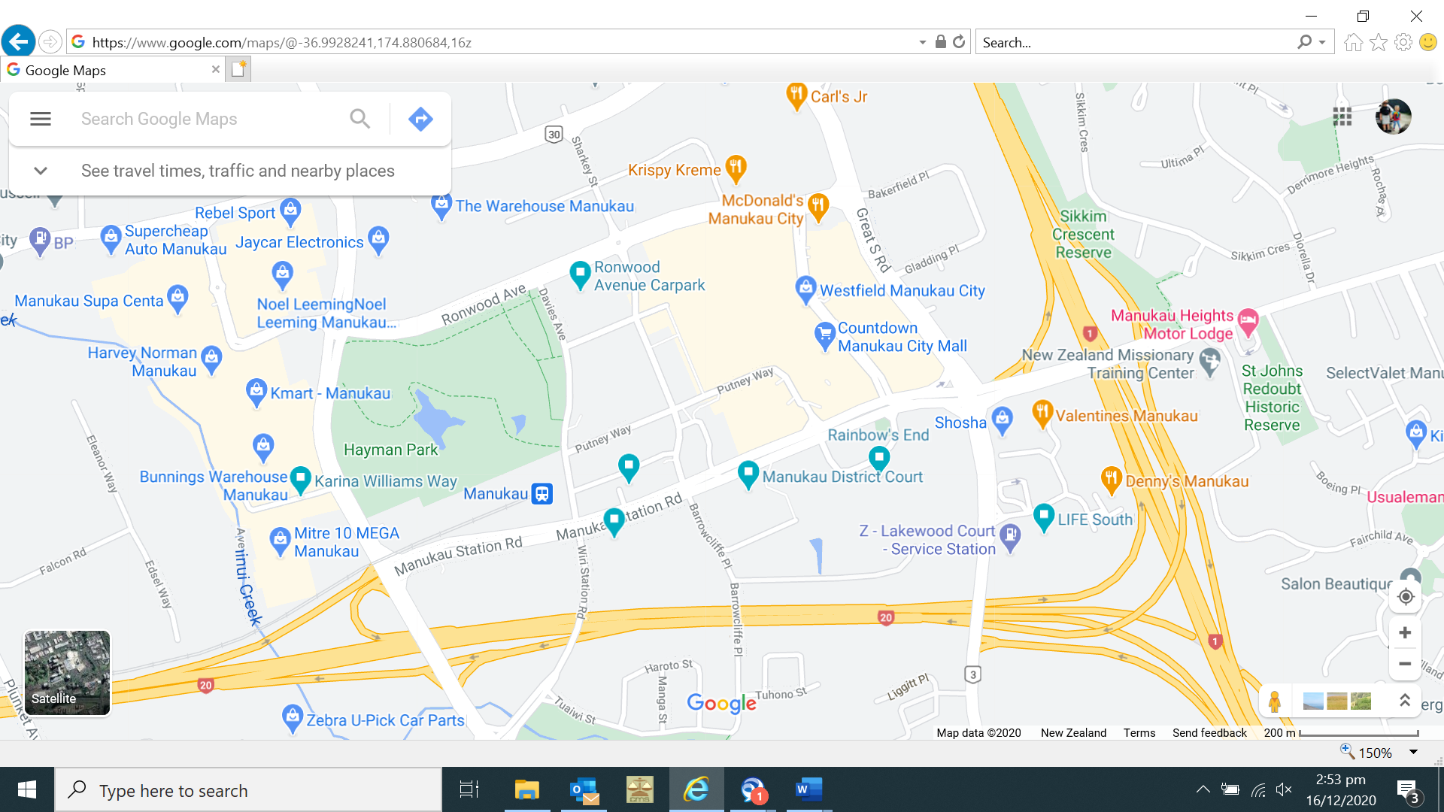

**1**

**2**

**3**

**4**

**5**